**PRACTICAL NO 1**

**Q.)Write a test suite containing minimum 4 test cases for different websites.**

**Download selenium idle for Mozilla firefox**[**http://www.seleniumhq.org**](http://www.seleniumhq.org/)

1. Open any web browser which has selenium IDE installed in it.
2. Start selenium IDE.
3. Click on record a new test in new project.
4. Give a name to your project.
5. Specify the base URL and click on Start Recording.

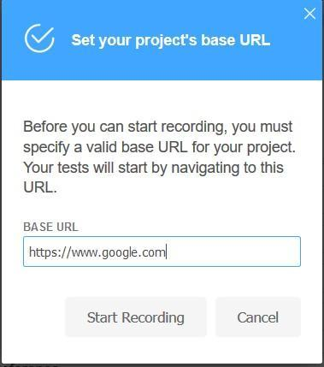

1. Now start recording your test case.

**Test case 1:**

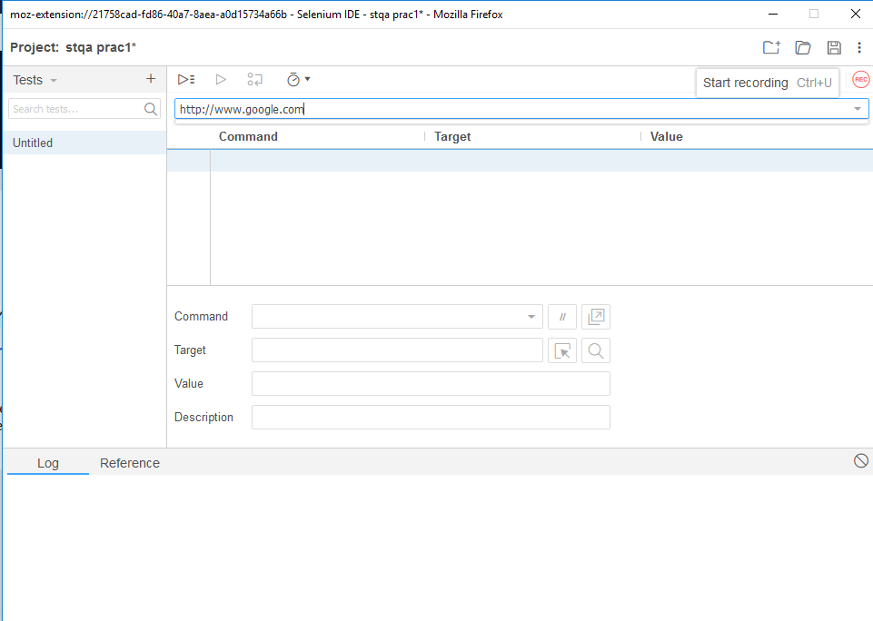

Step 7: -Name the test case as test1

Step 8: -Run the test

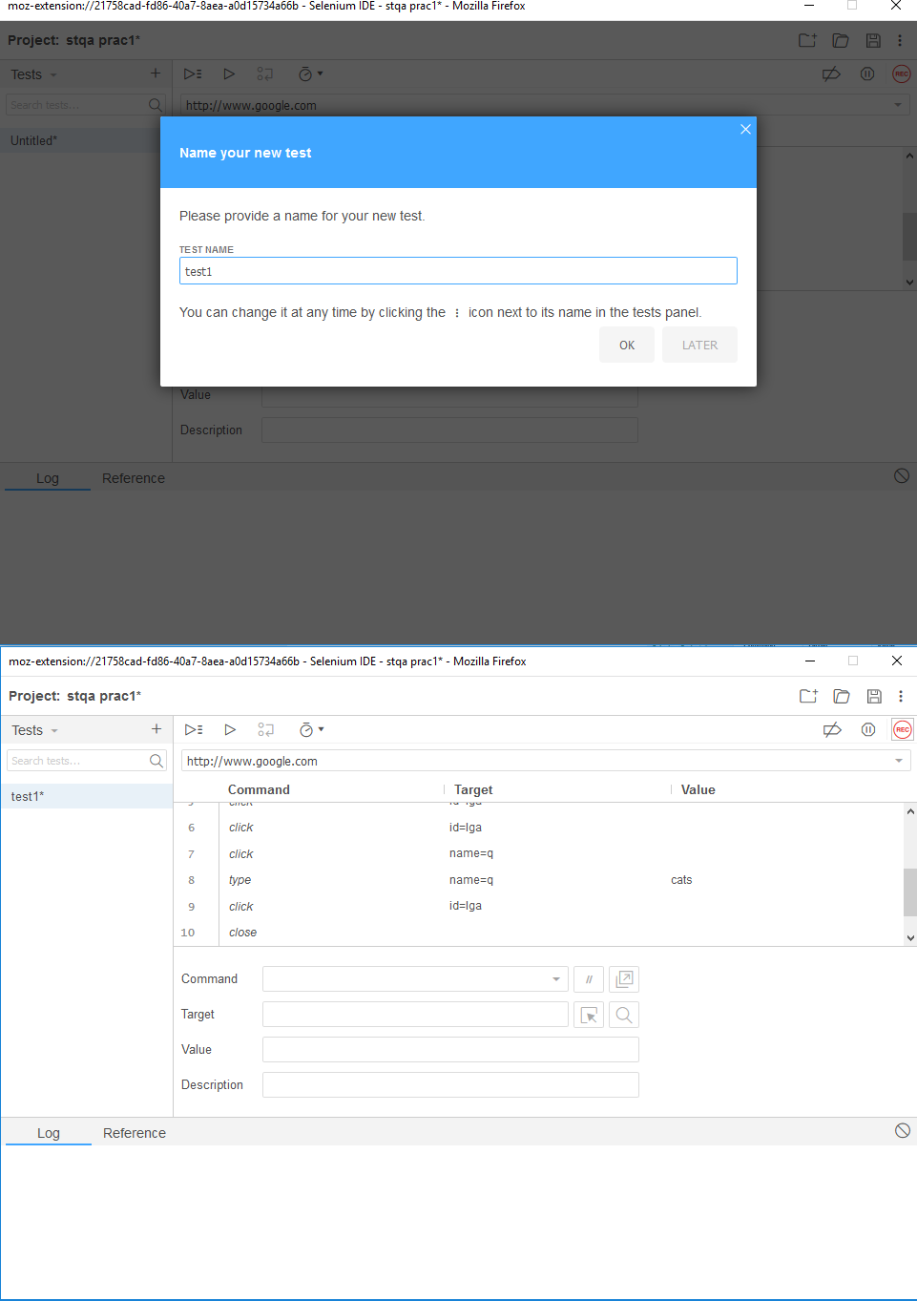

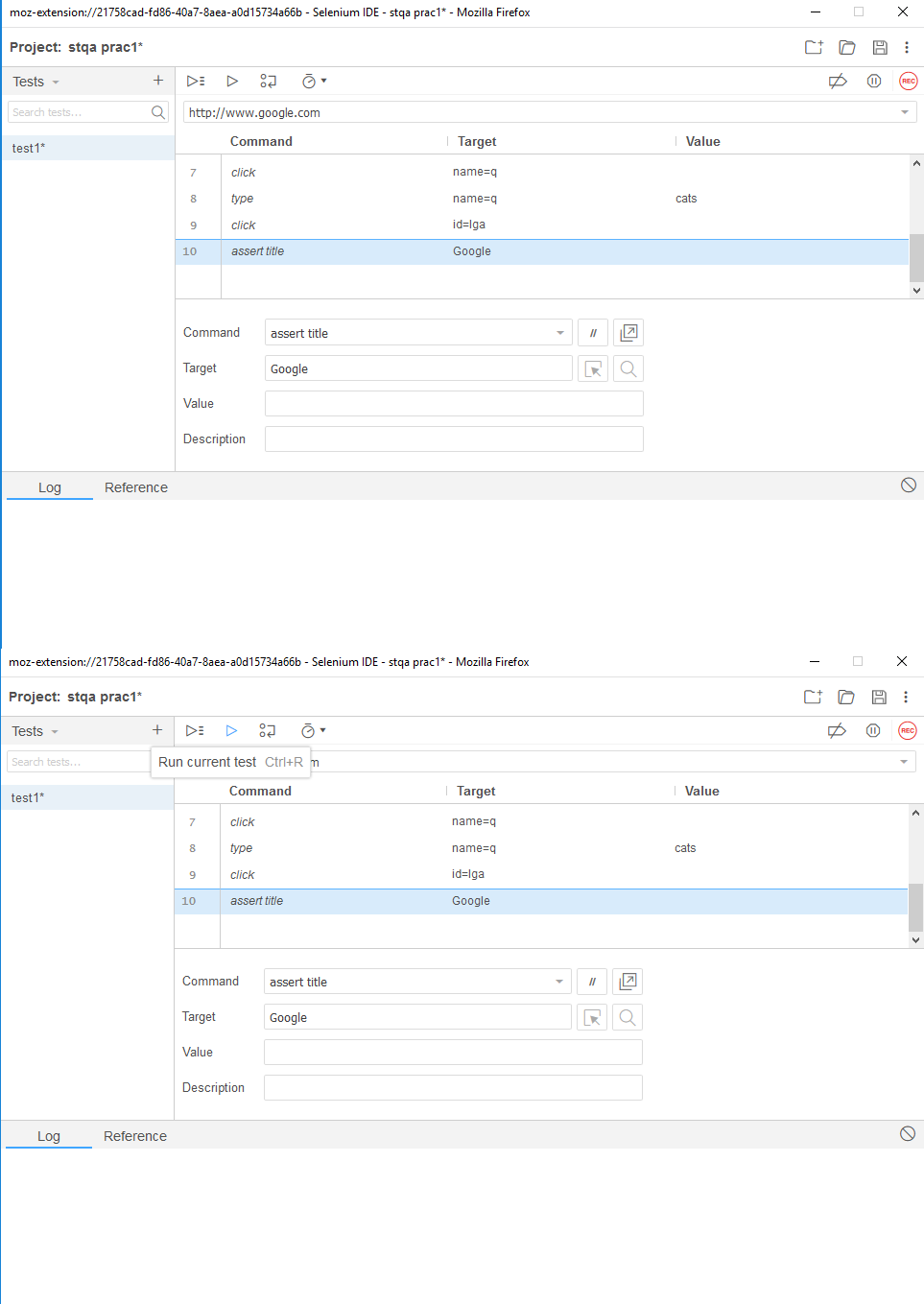

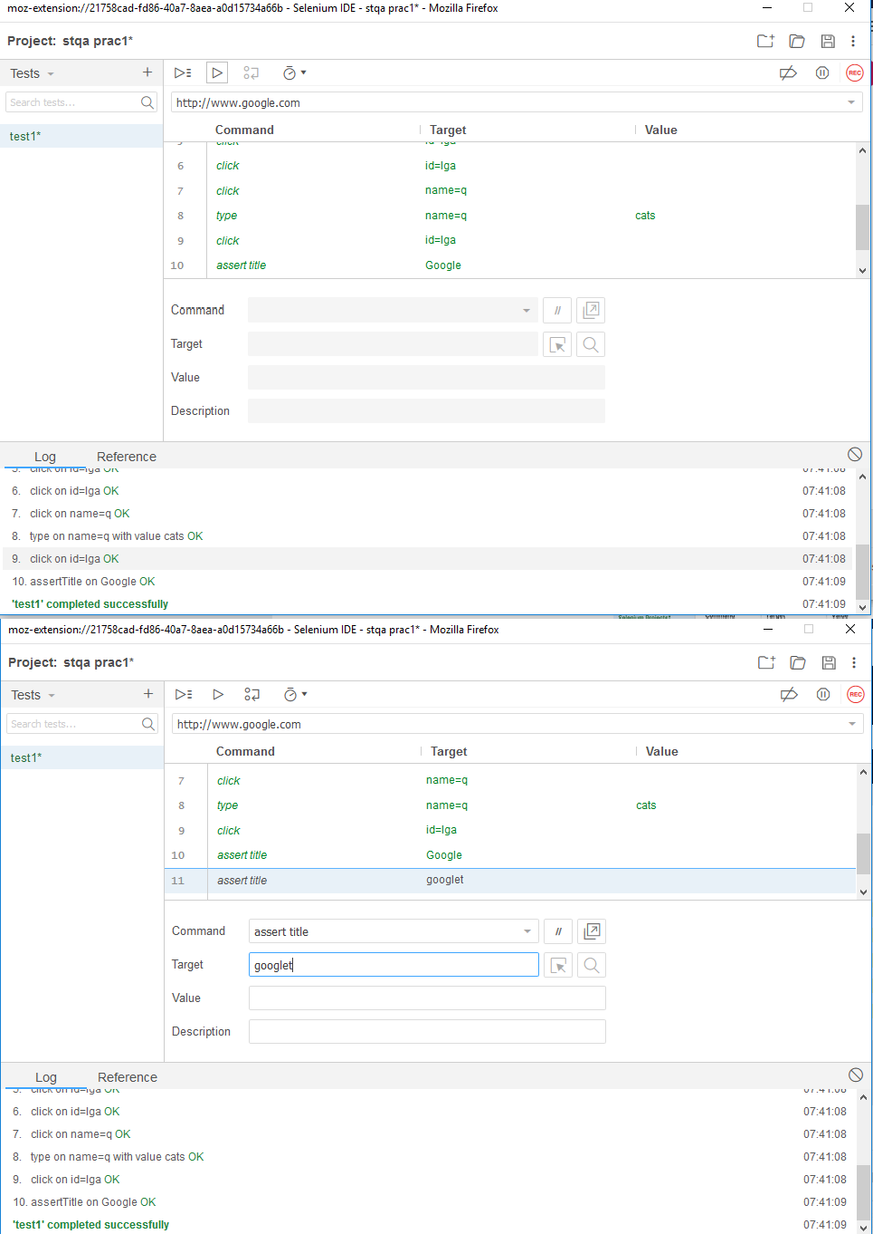

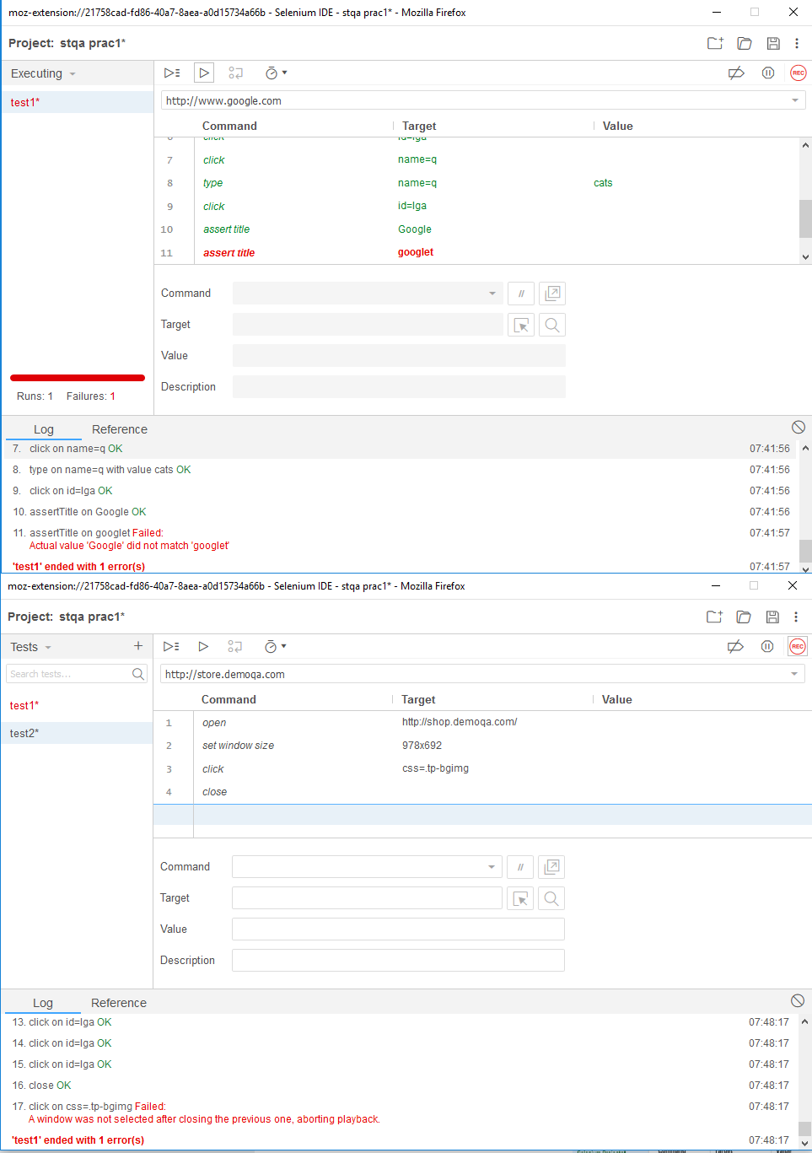

**Test case 2:**

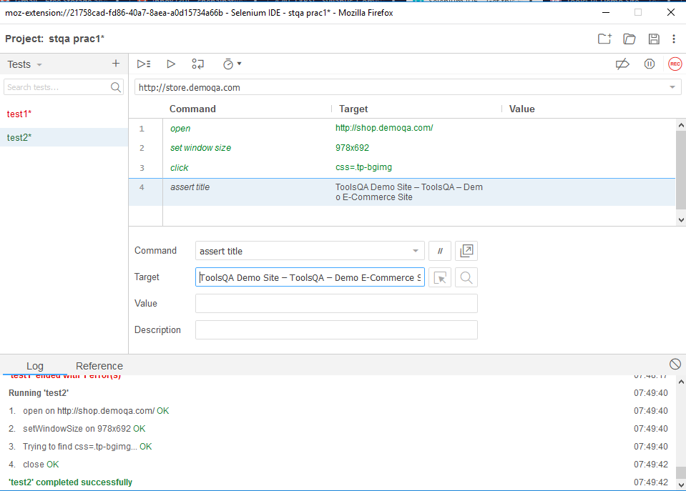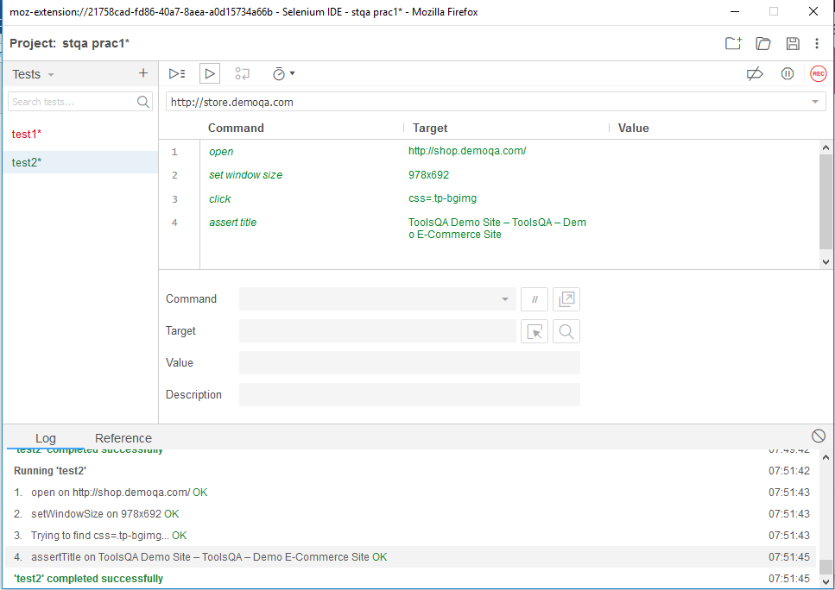

**Test case 3:**

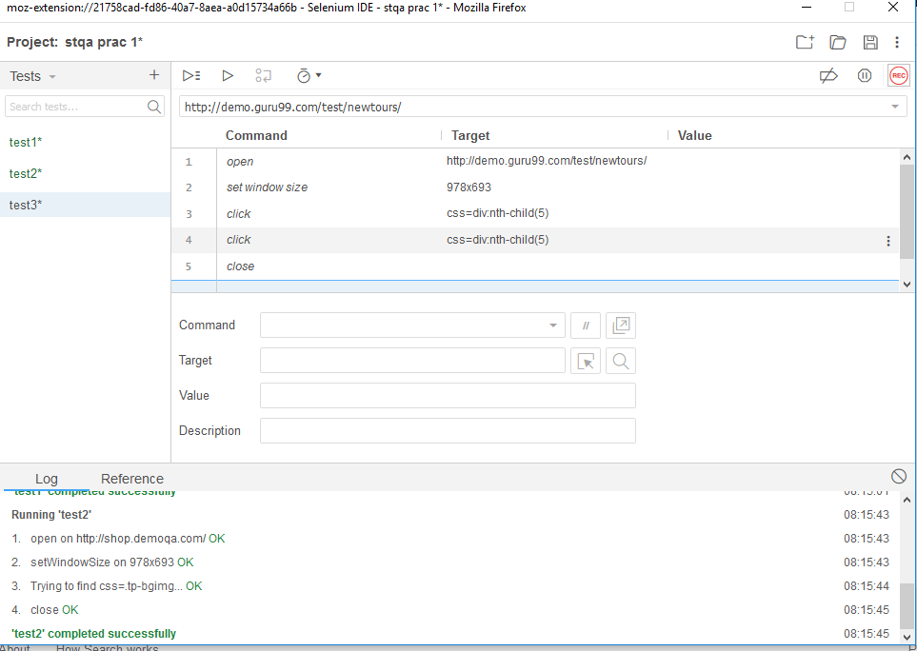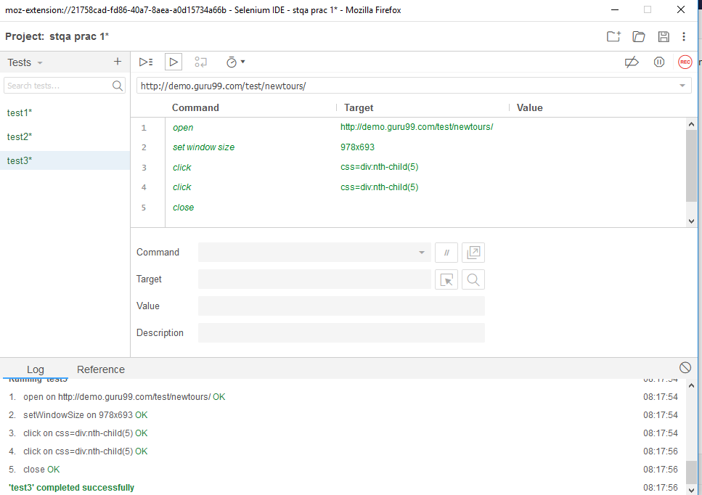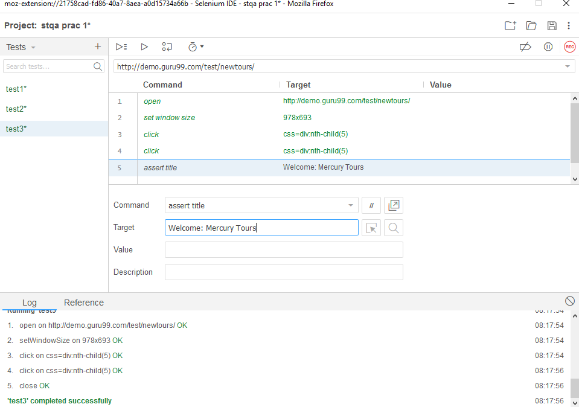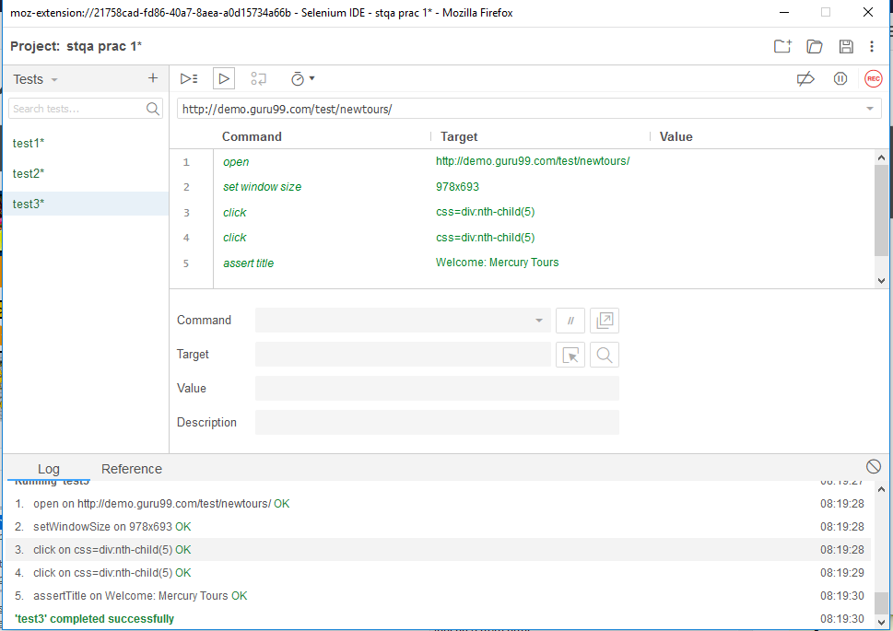

**Test case 4:**

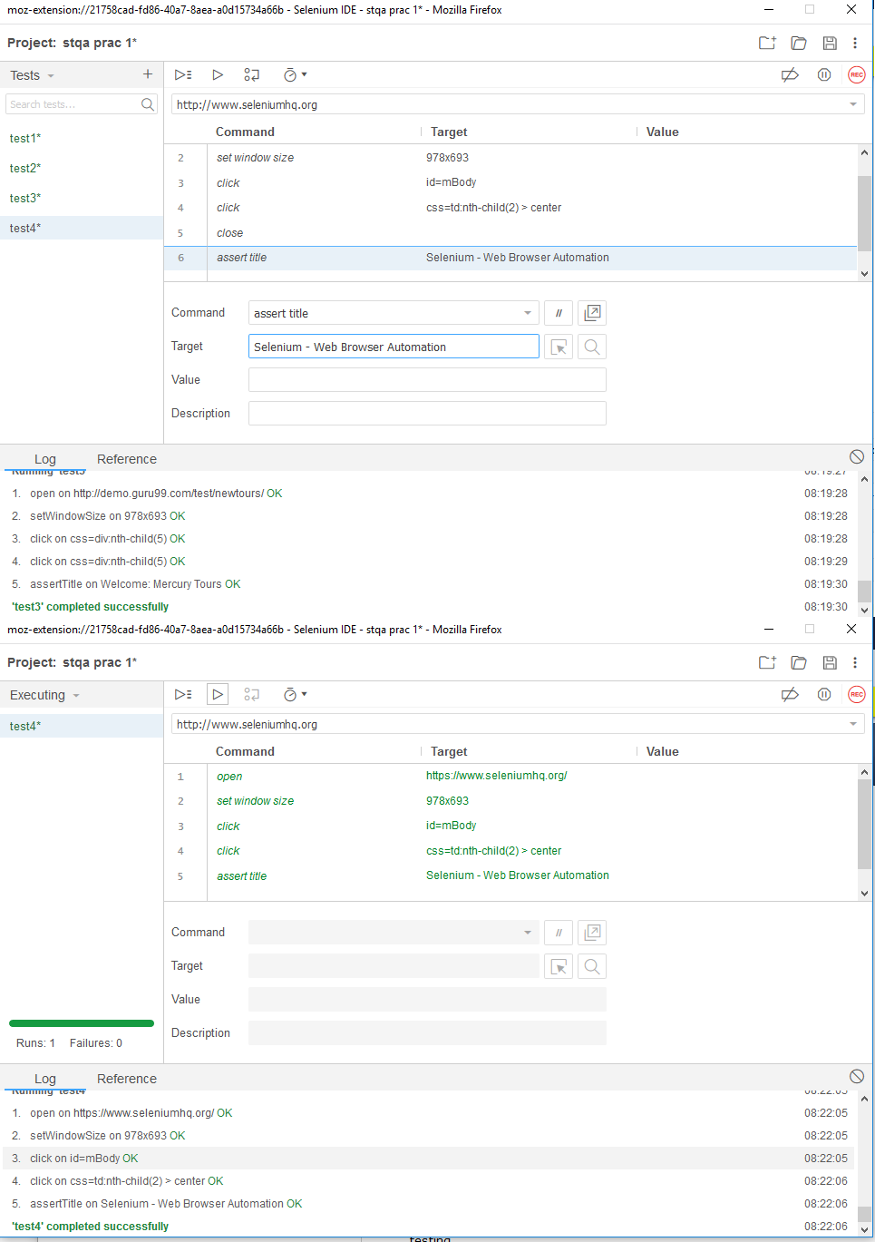

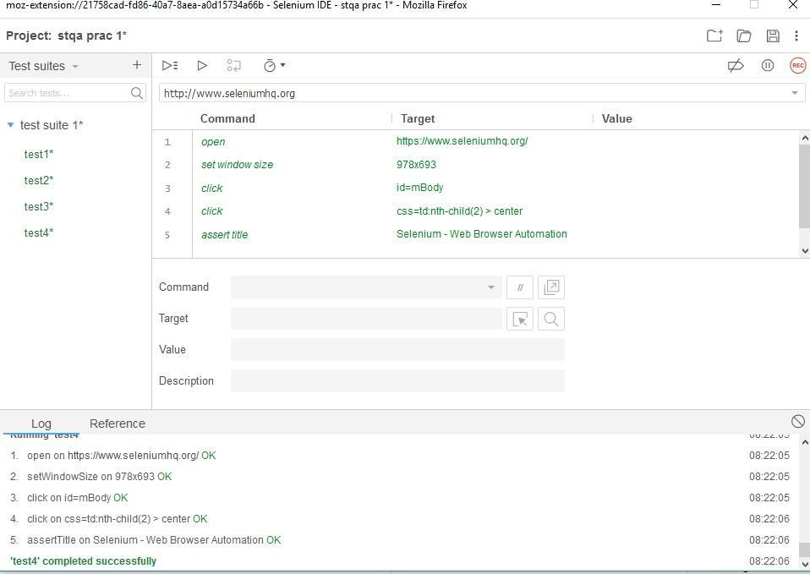

**PRACTICAL NO 2**

**Q.)Conduct a test suite for http://bhavans.ac.in/ college website.**

**Step 1) Open a Selenium IDE and Create a new project**

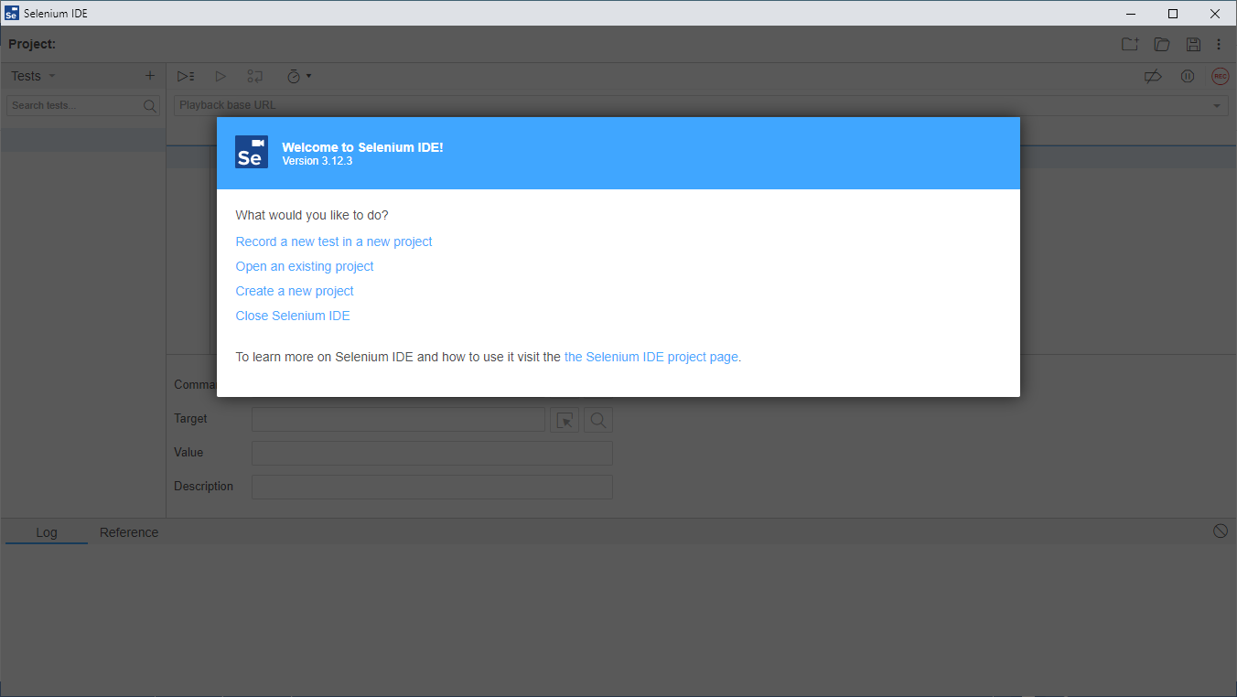

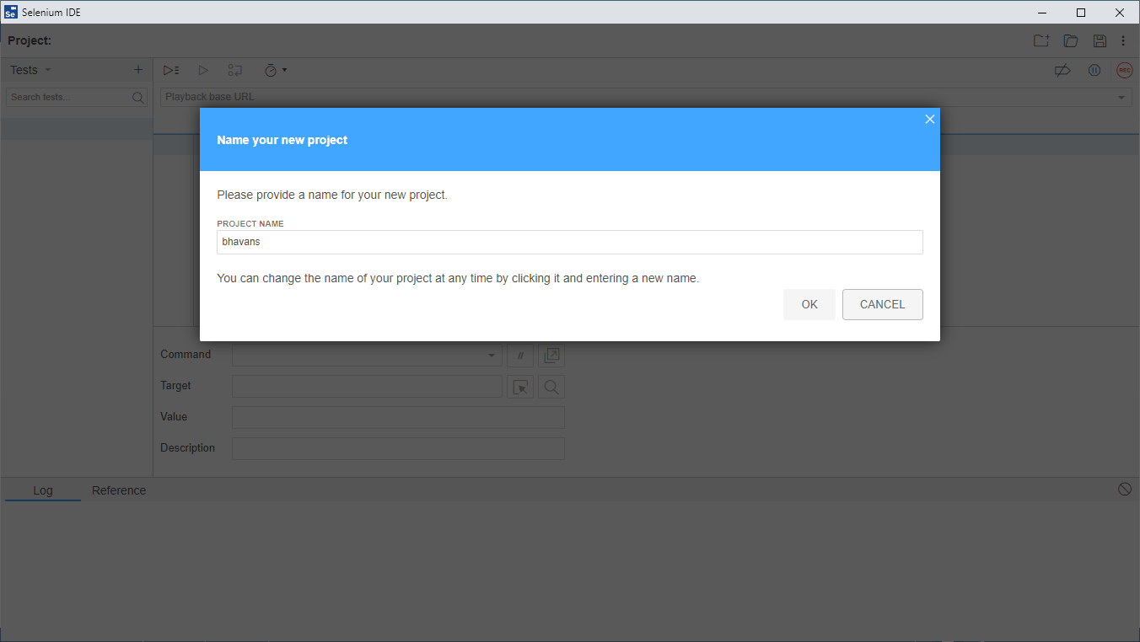

**Step 2) Write the url into blaybackurl**

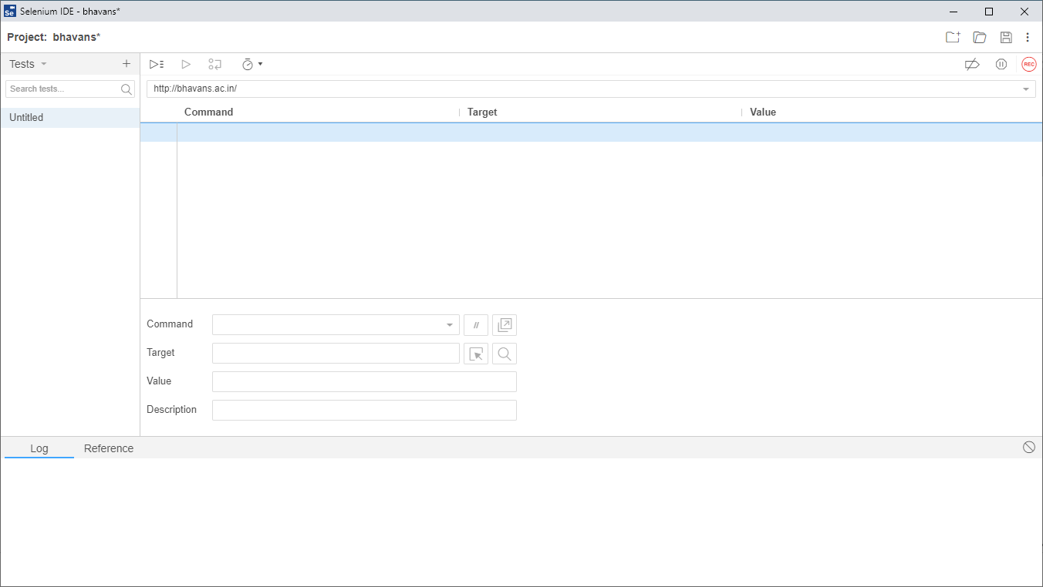

**Step 3) Start Recording**

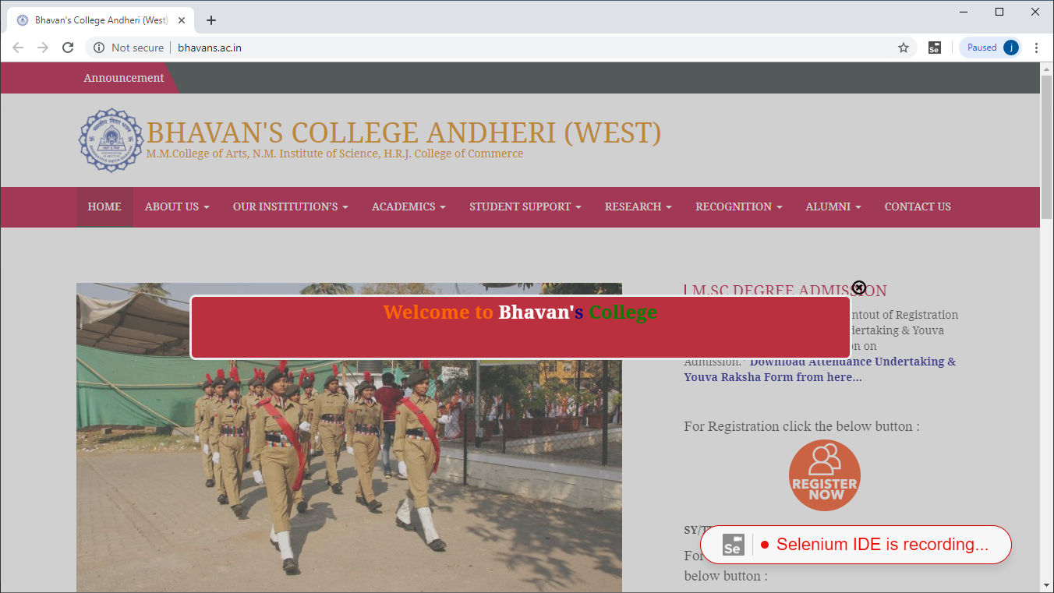

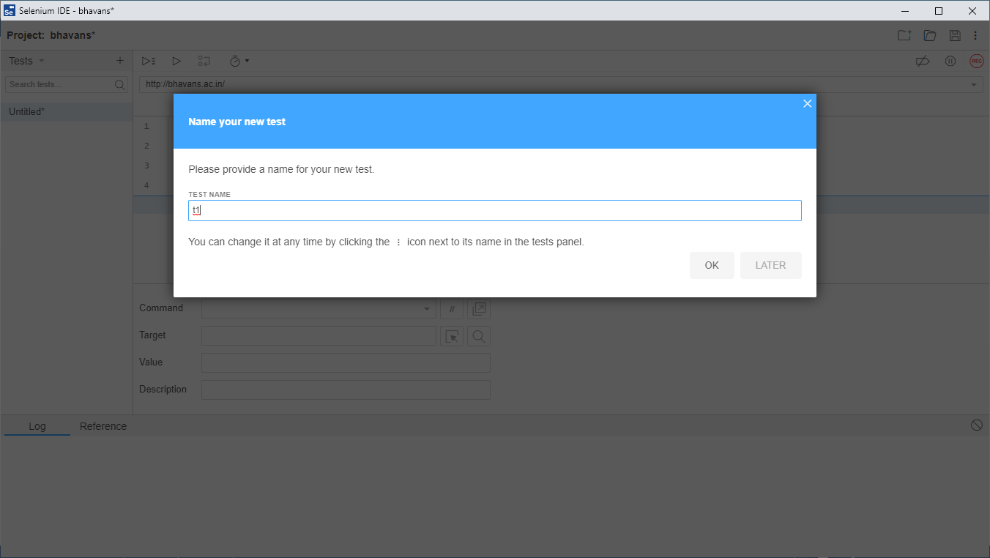

**Step 4) Click on Run**

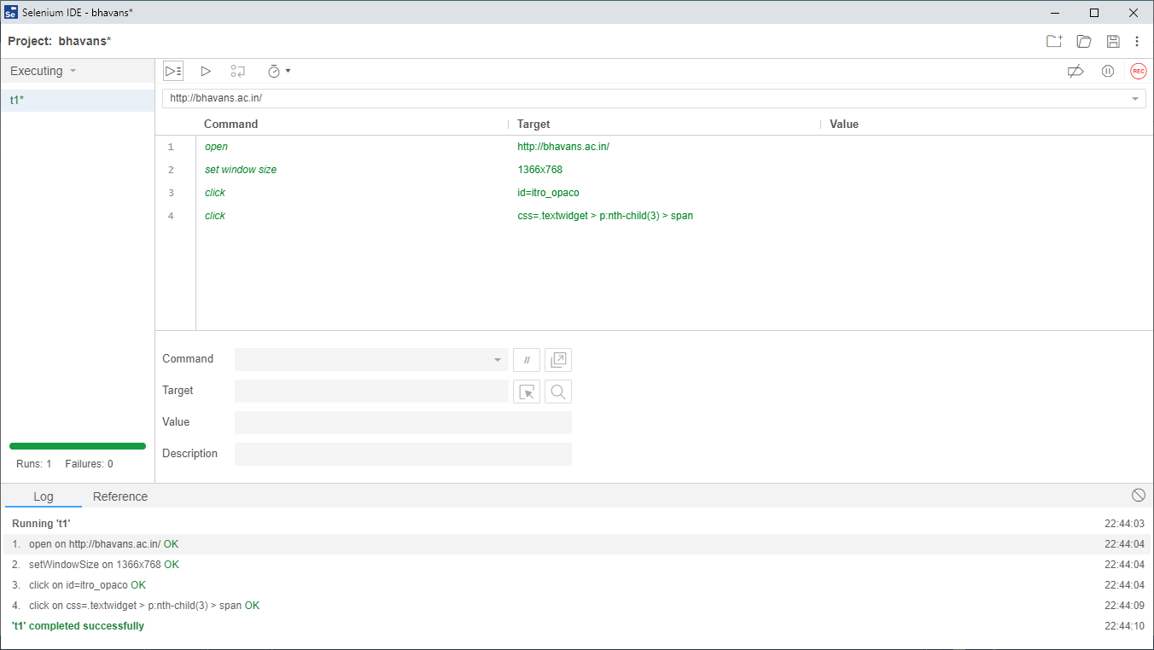

**For Test case 2(Assert title):**

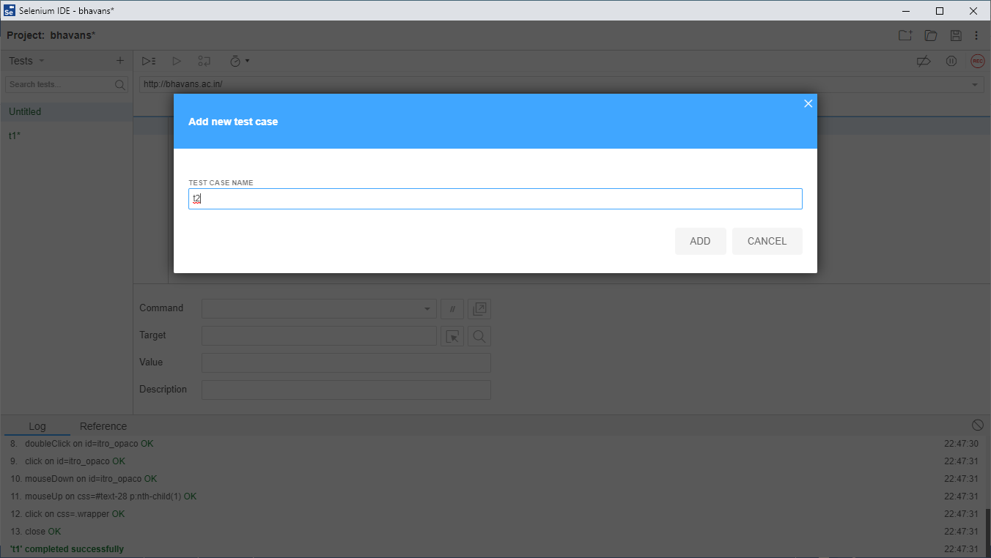

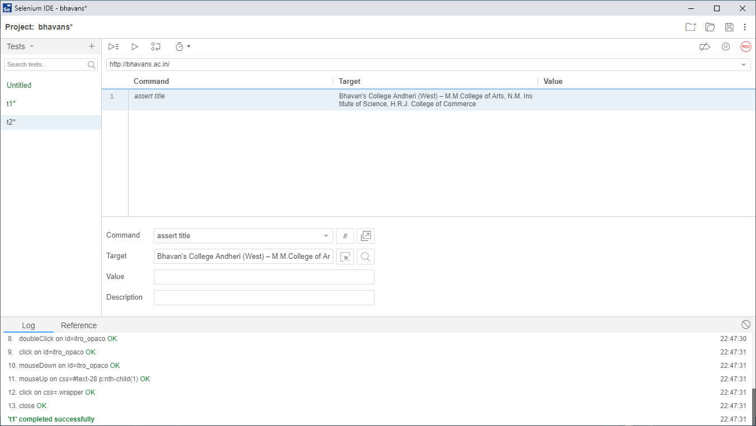

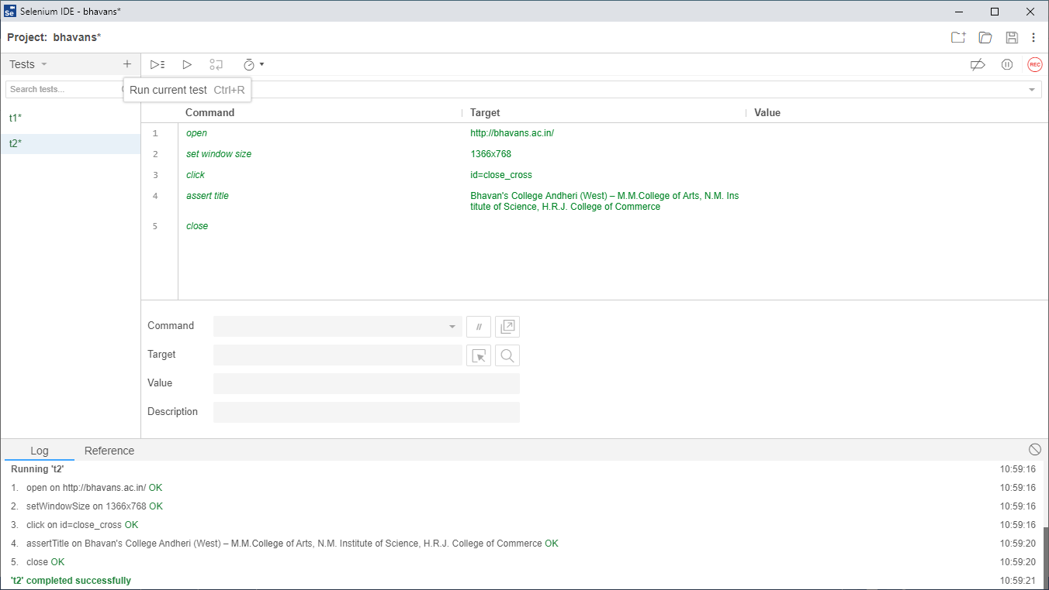

**For Test case 3 (Verify text):**

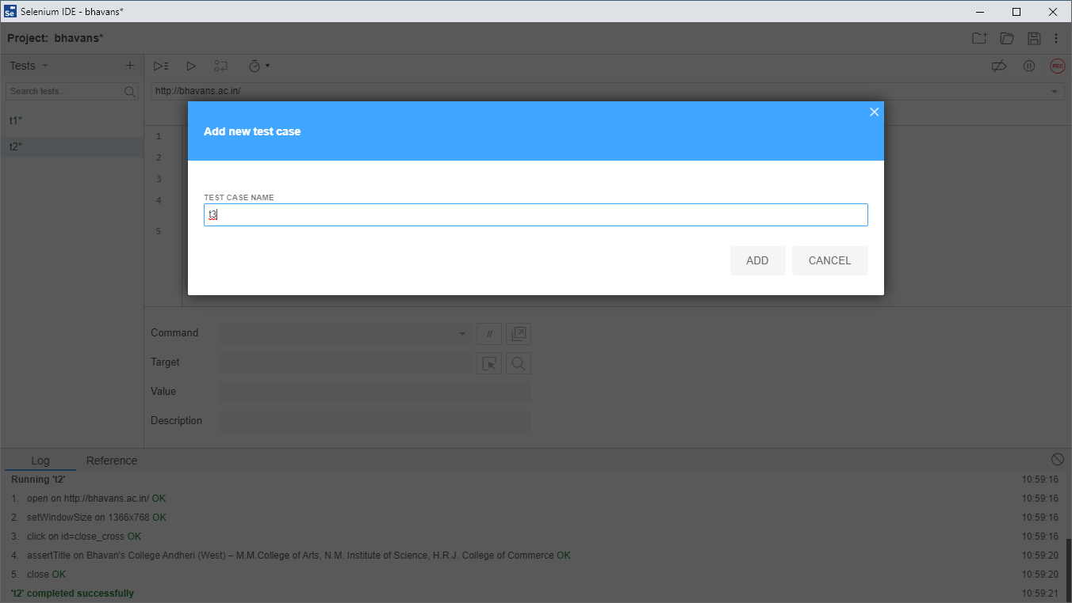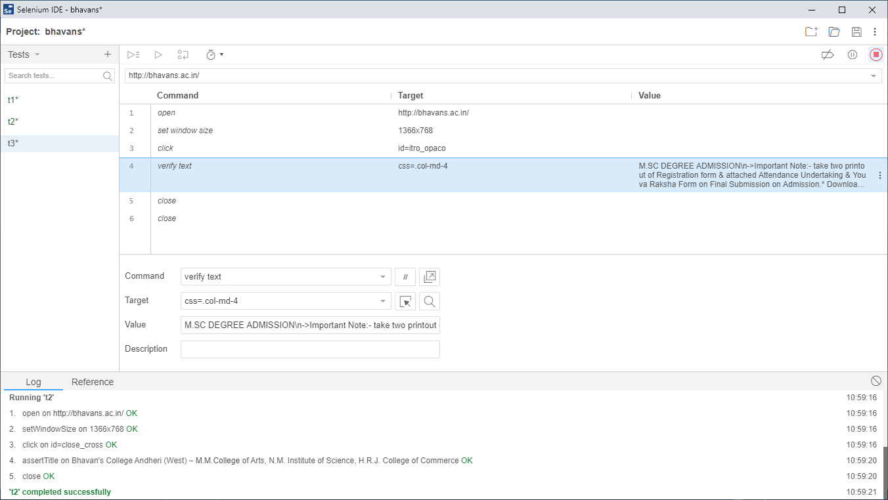

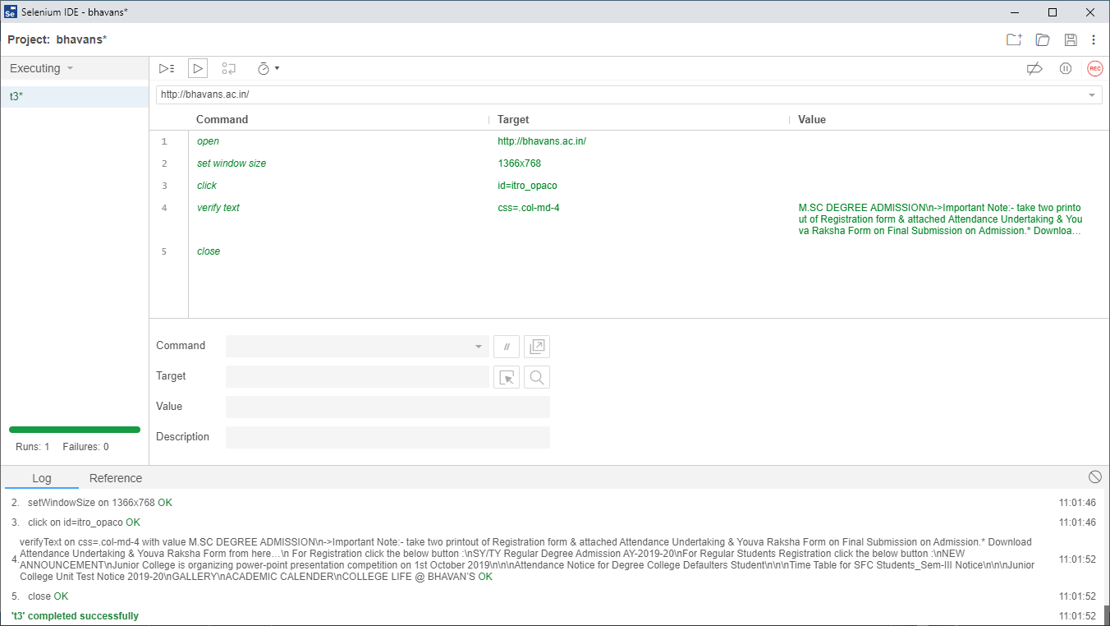

**Test Suite :**

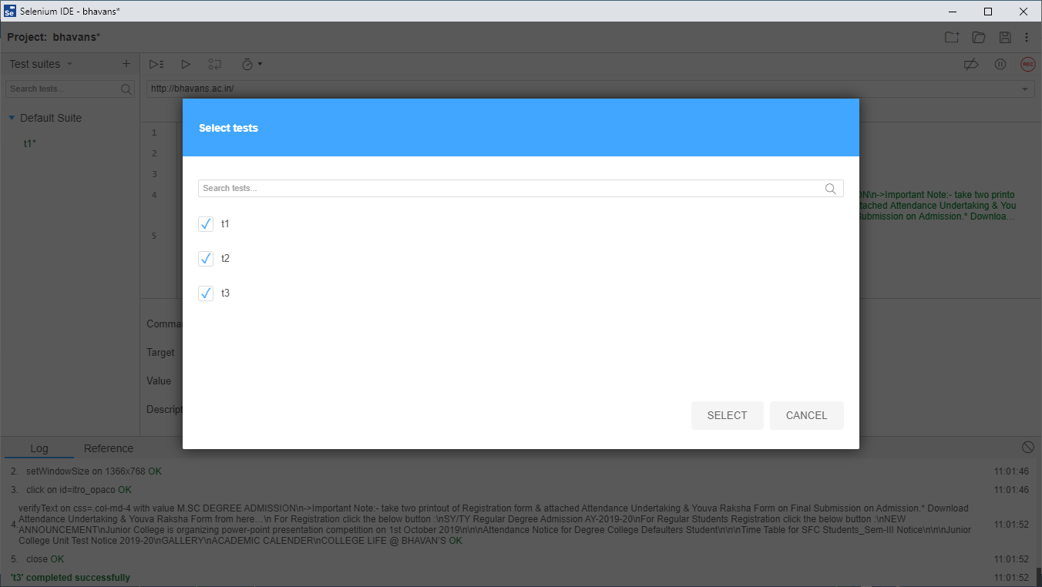

**Click on All run all test in suite :**

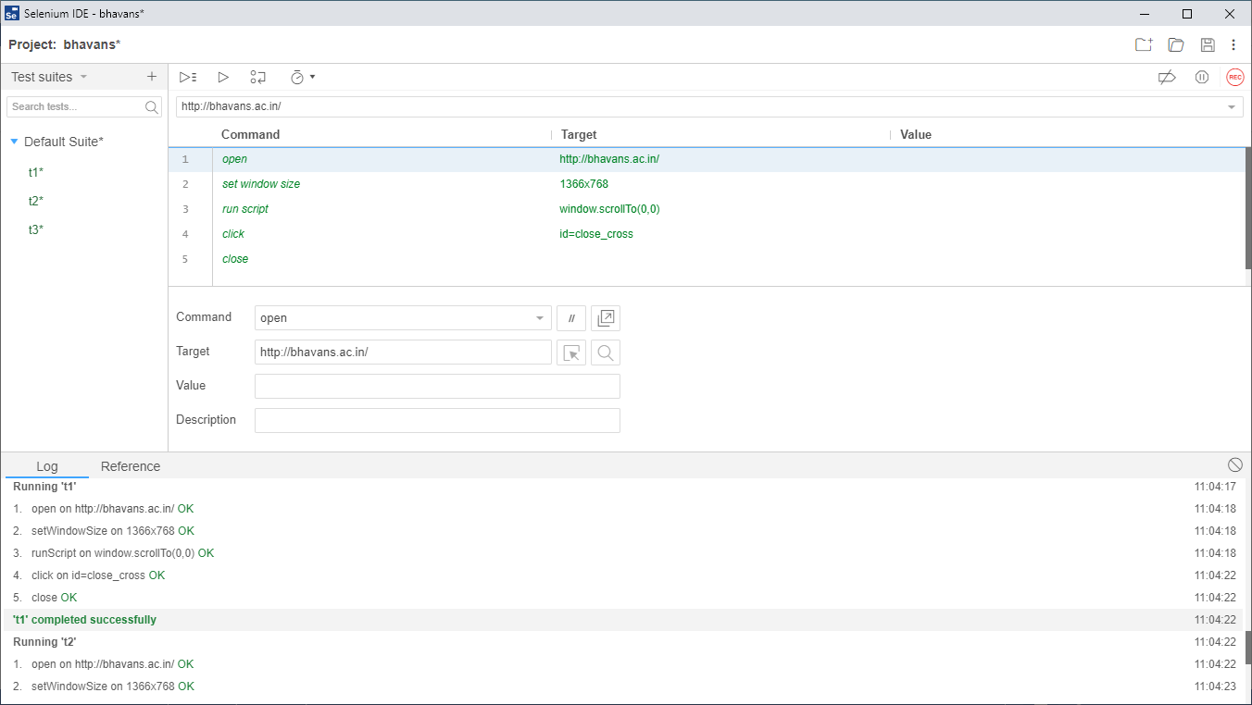

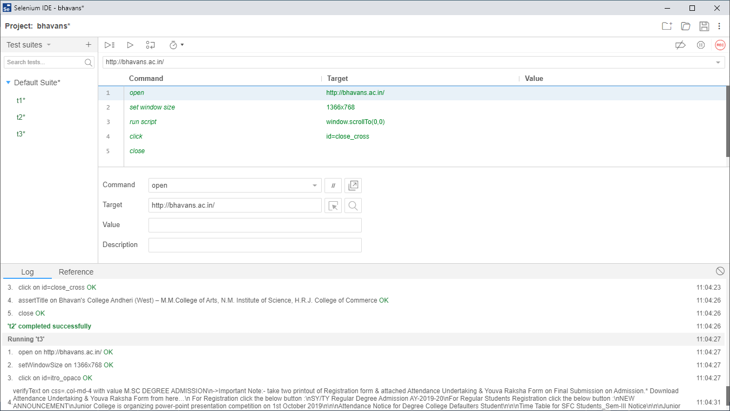

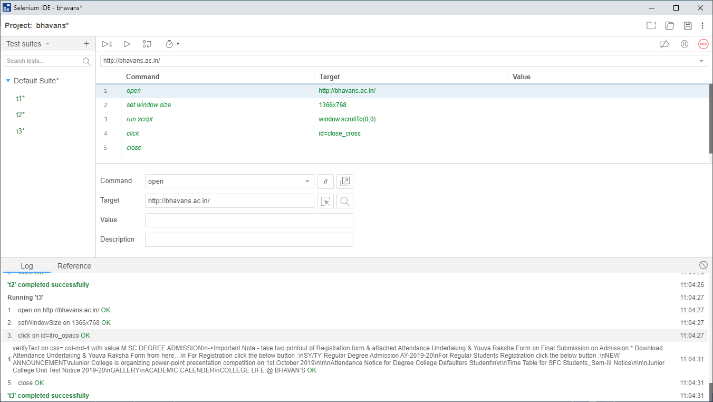

**PRACTICAL NO 3**

**Q.)Write test case to demonstrate the following selenium commands:**

1. Assert title
2. Verify title
3. Assert text
4. Verify text
5. Verify element

**Testcase1:**

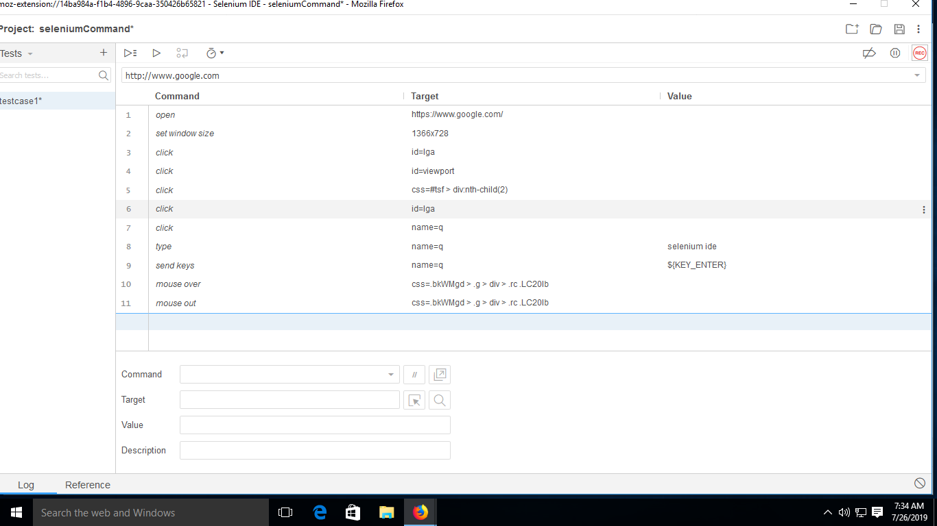

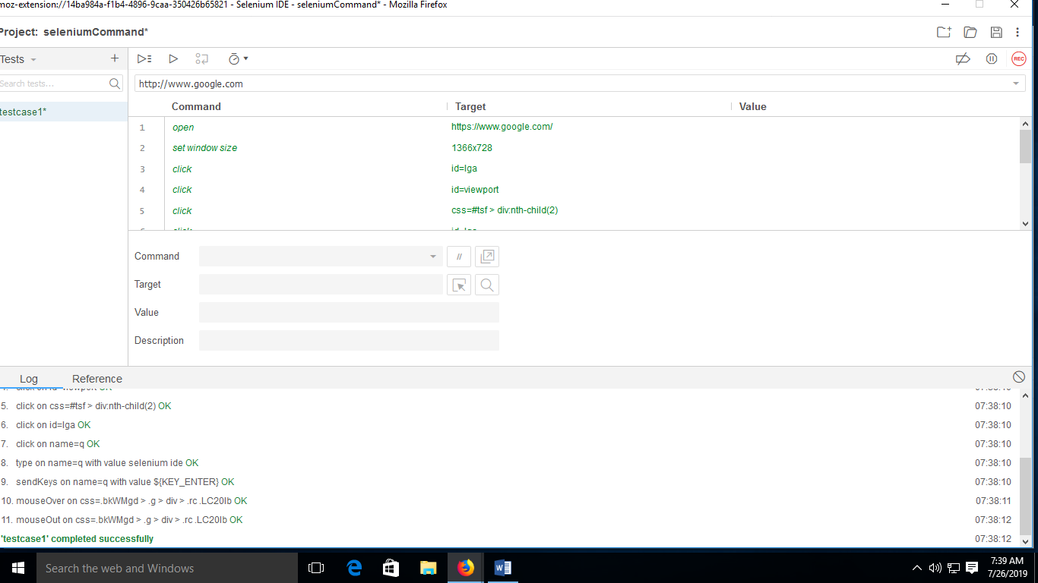

**Automate Testing:**

**Testcase2**

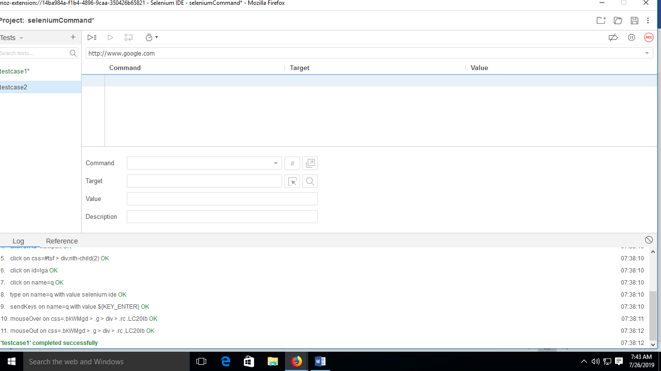

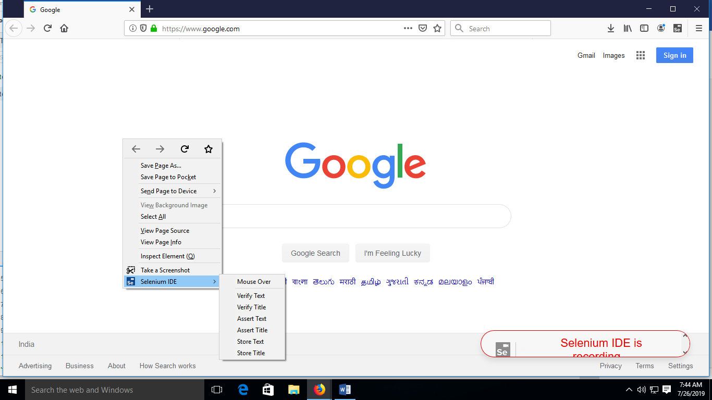

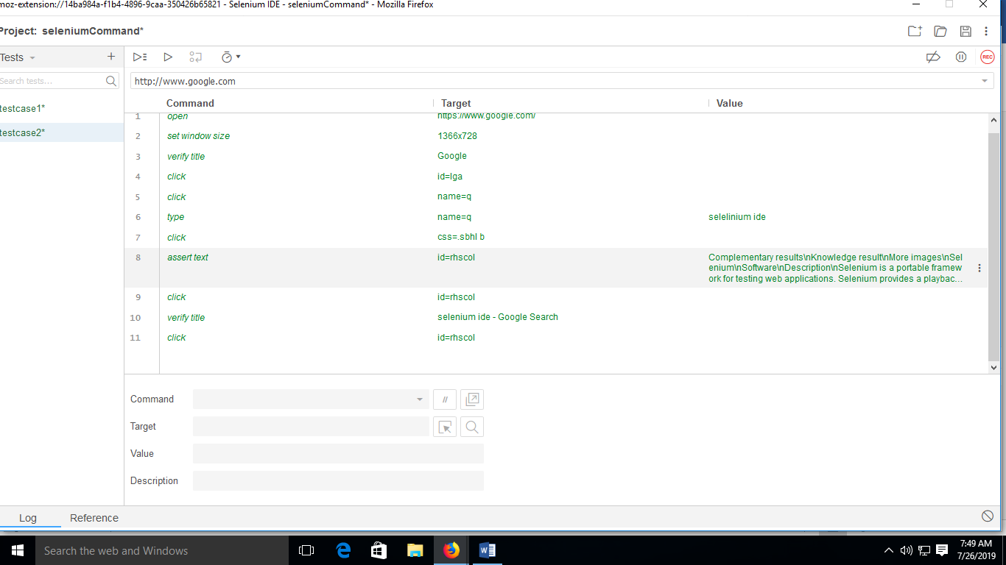

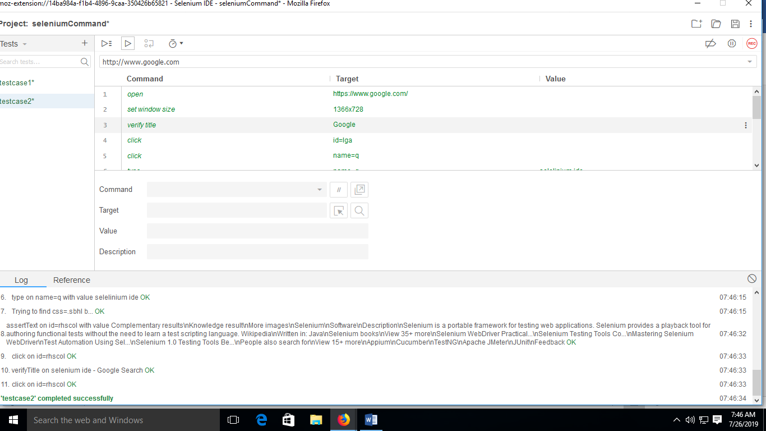

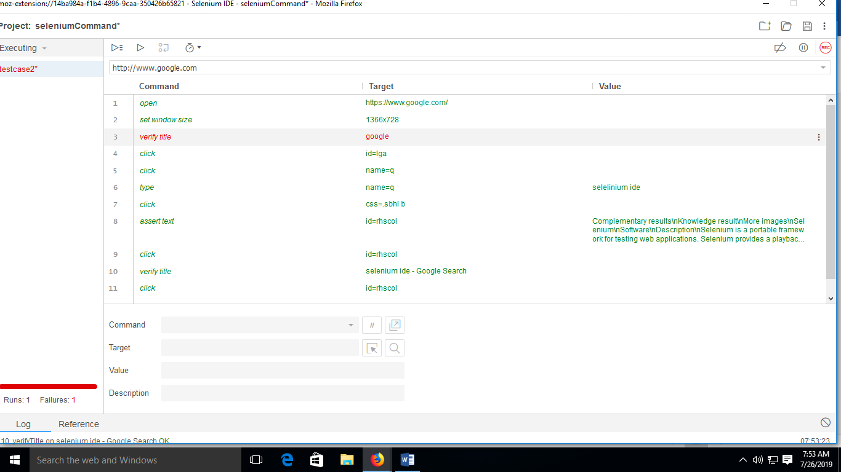

**Testcase3**

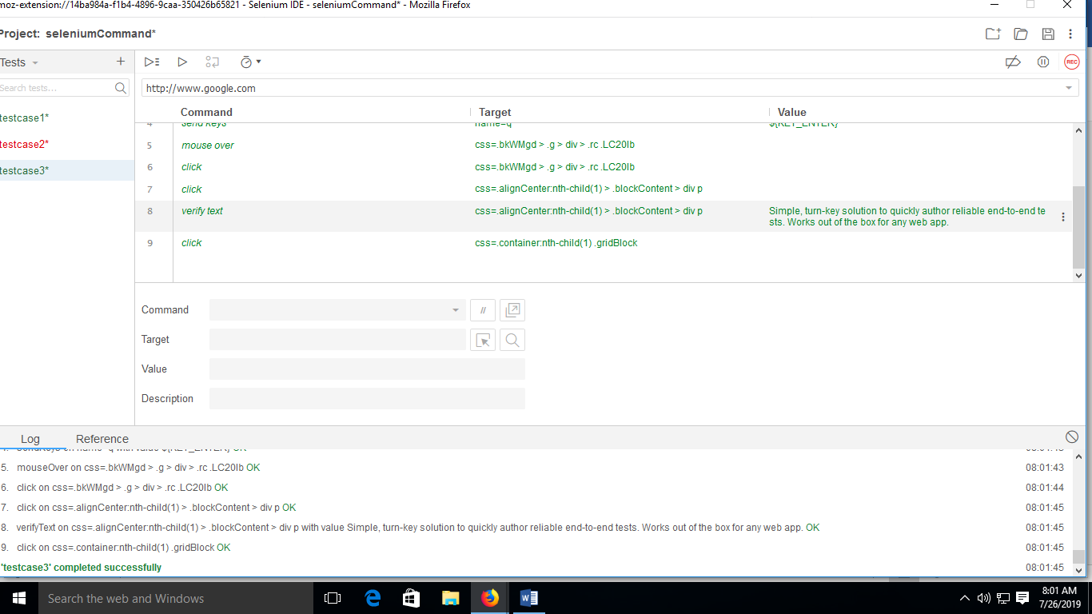

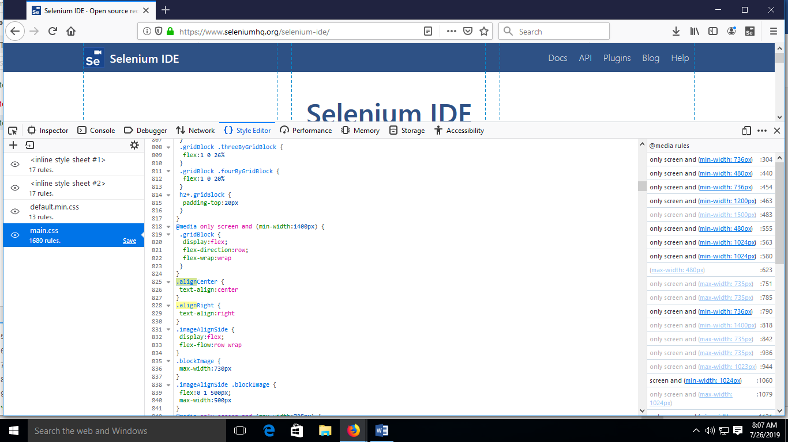

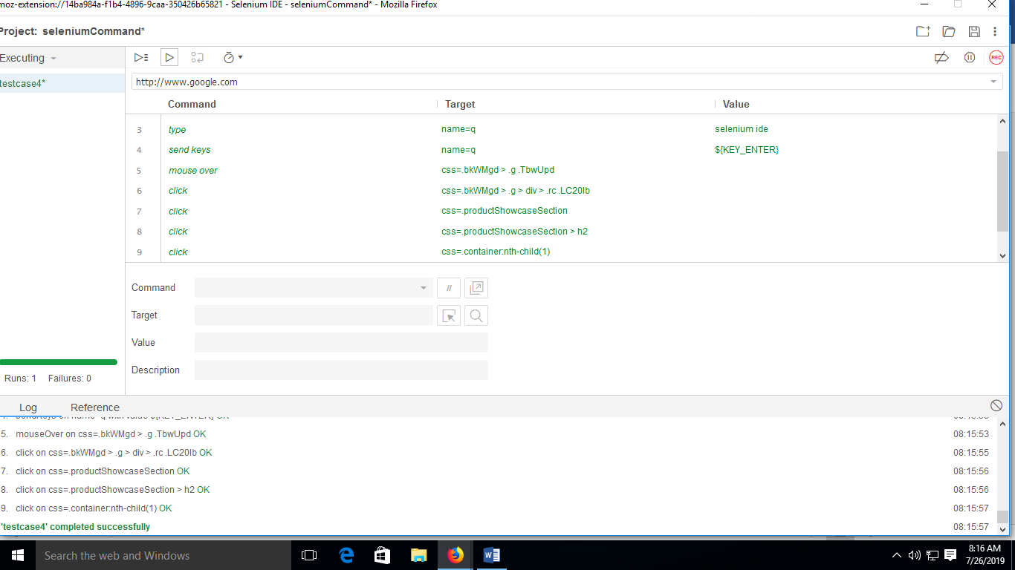

**Manually Entering commands:**

**Testcase4**

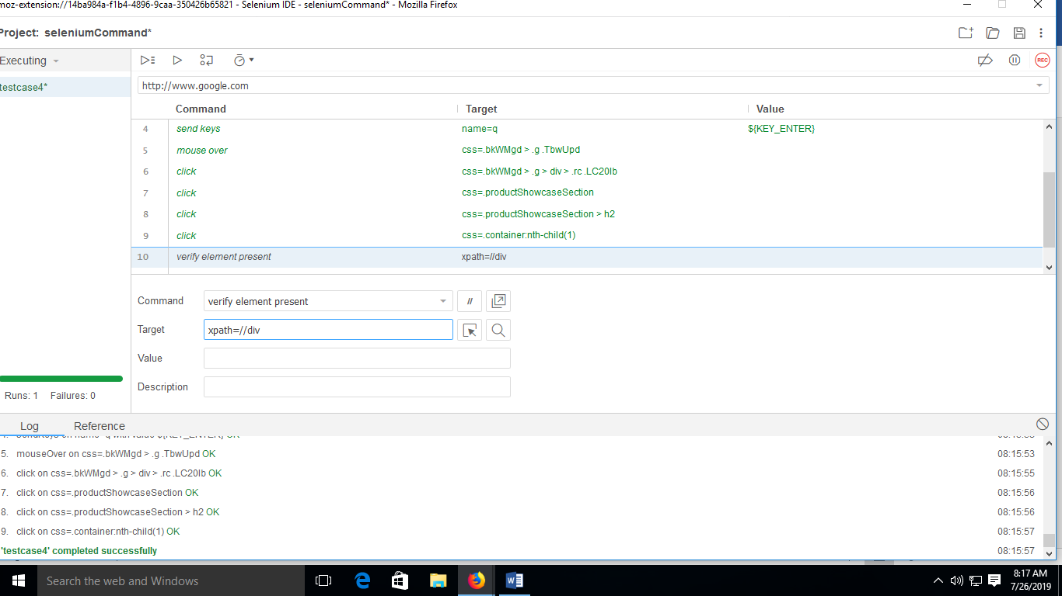

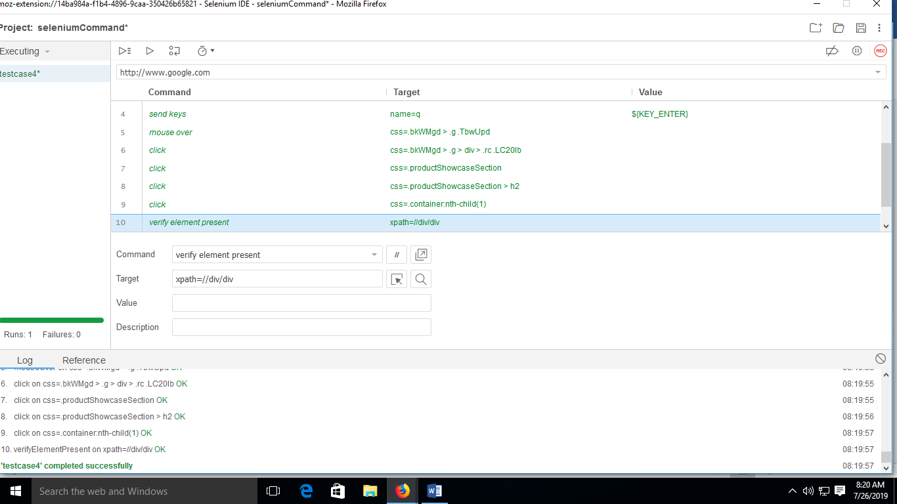

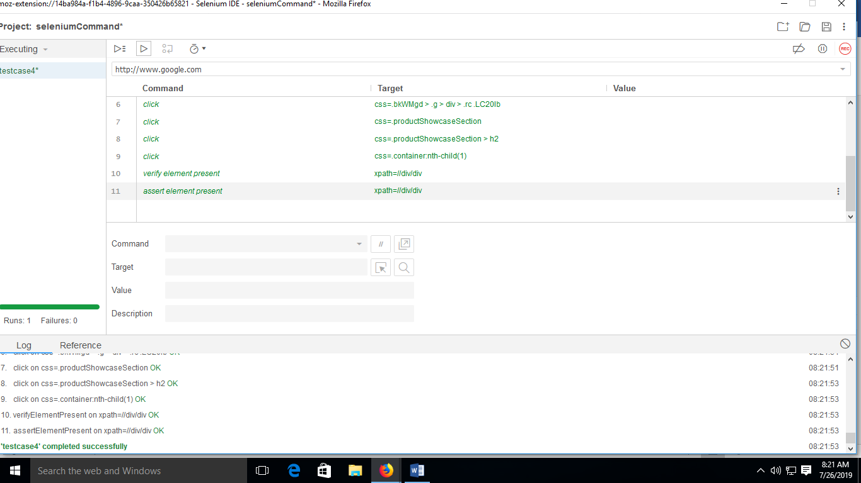

**TestSuite**

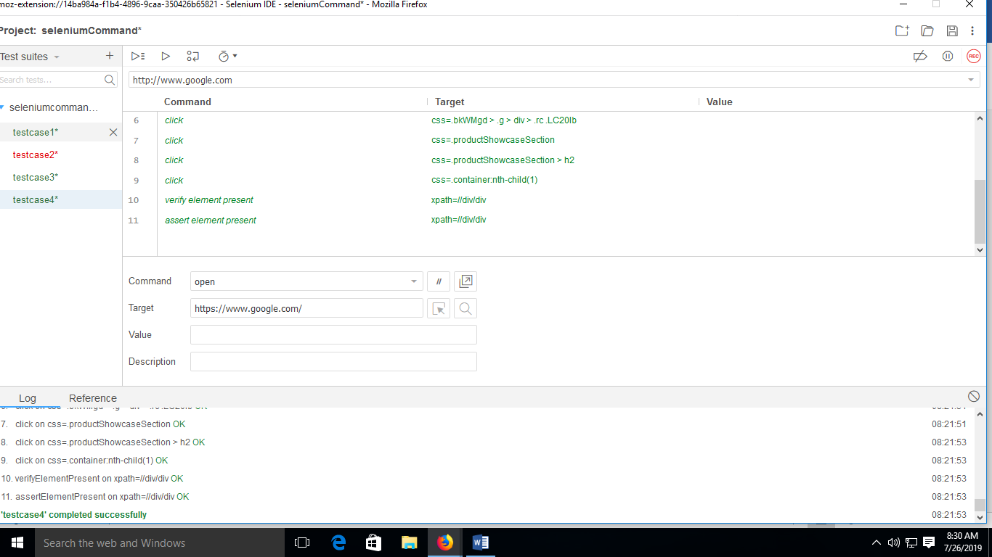

**PRACTICAL NO 4**

**Q.)Install Selenium server (Selenium RC) and demonstrate it using a script in Java/PHP.**

**Download:**

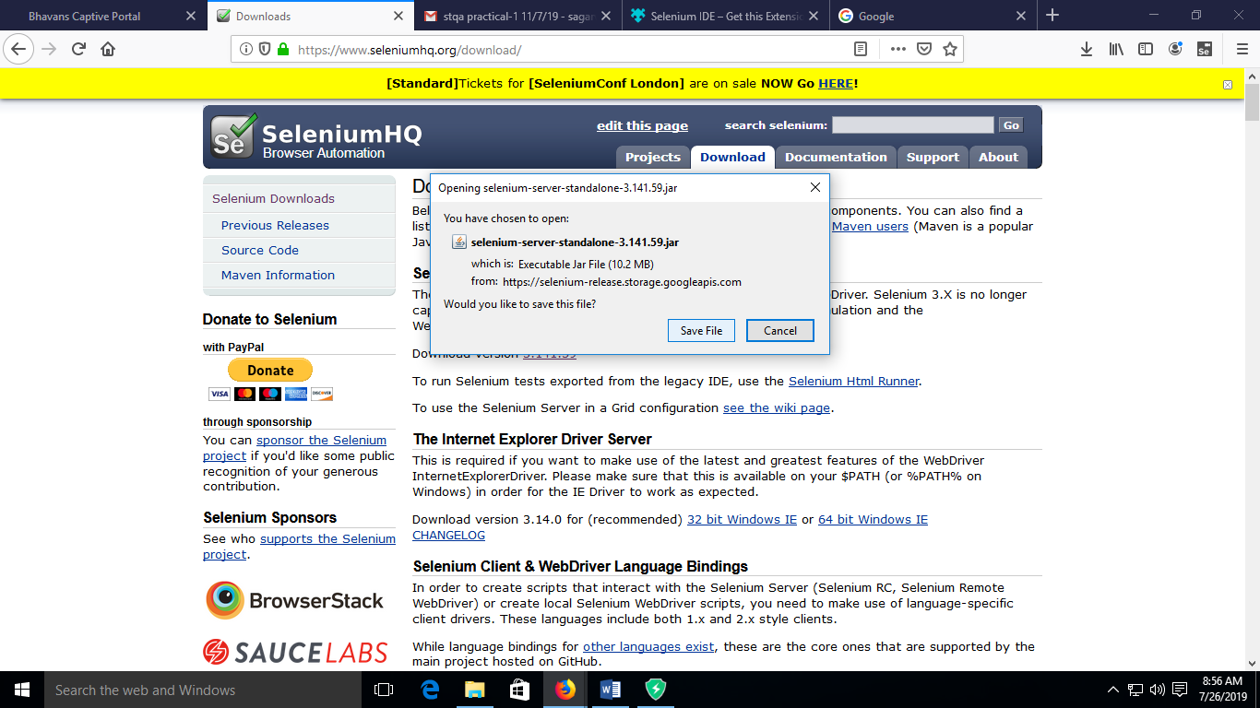

**And also download the java file**

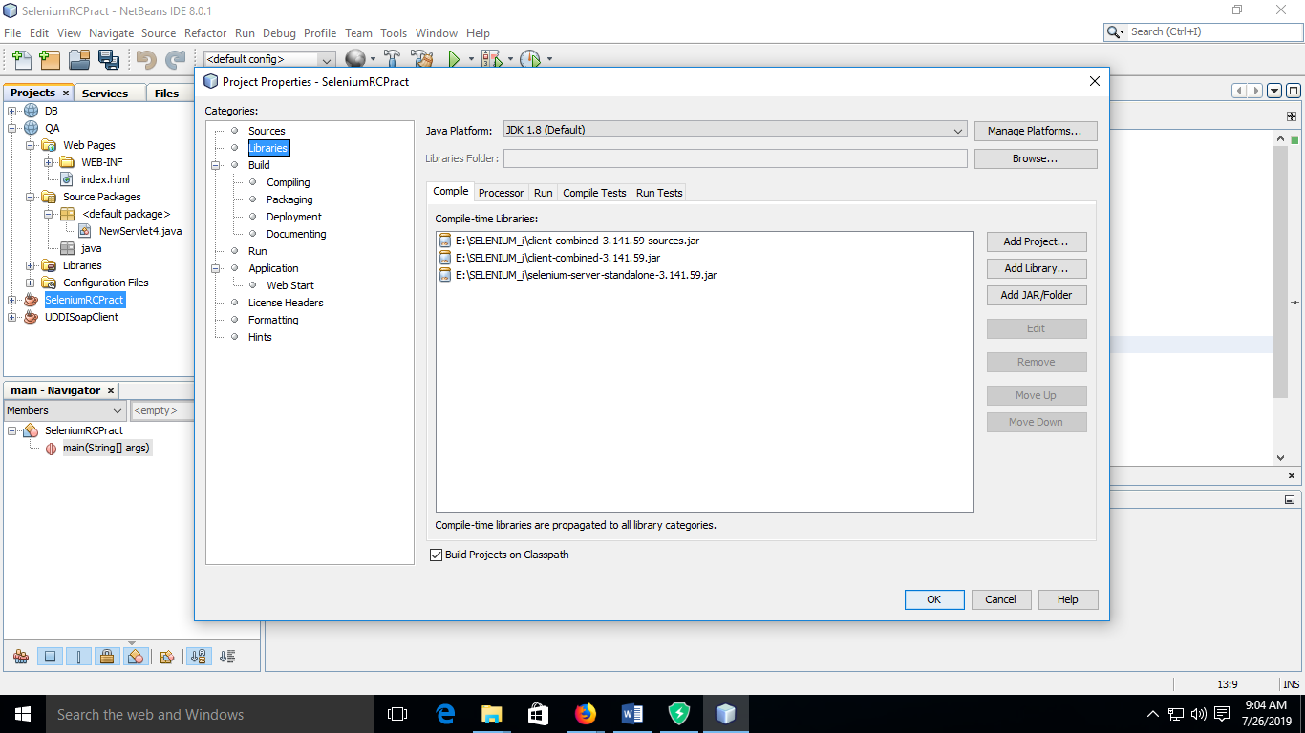

**Code:**

package seleniumrcpract;

import org.openqa.selenium.WebDriver;

import org.openqa.selenium.firefox.FirefoxDriver;

import org.openqa.selenium.remote.DesiredCapabilities;

public class SeleniumRCPract {

static String driverpath="E:\\SELENIUM_i\\geckodriver.exe";

public static WebDriver driver;

public static void main(String[] args) {

System.out.println("selenium RC Demo");

System.setProperty("webdriver.gecko.driver", driverpath);

DesiredCapabilities cap=DesiredCapabilities.firefox();

driver=new FirefoxDriver(cap);

driver.get("http://google.com");

String desiredTitle="Google";

String actualTitle="";

actualTitle=driver.getTitle();

if(actualTitle.contentEquals(desiredTitle))

System.out.println("test passed");

else

System.out.println("Test Passed");

driver.manage().window().maximize();

}

}

**Output:**



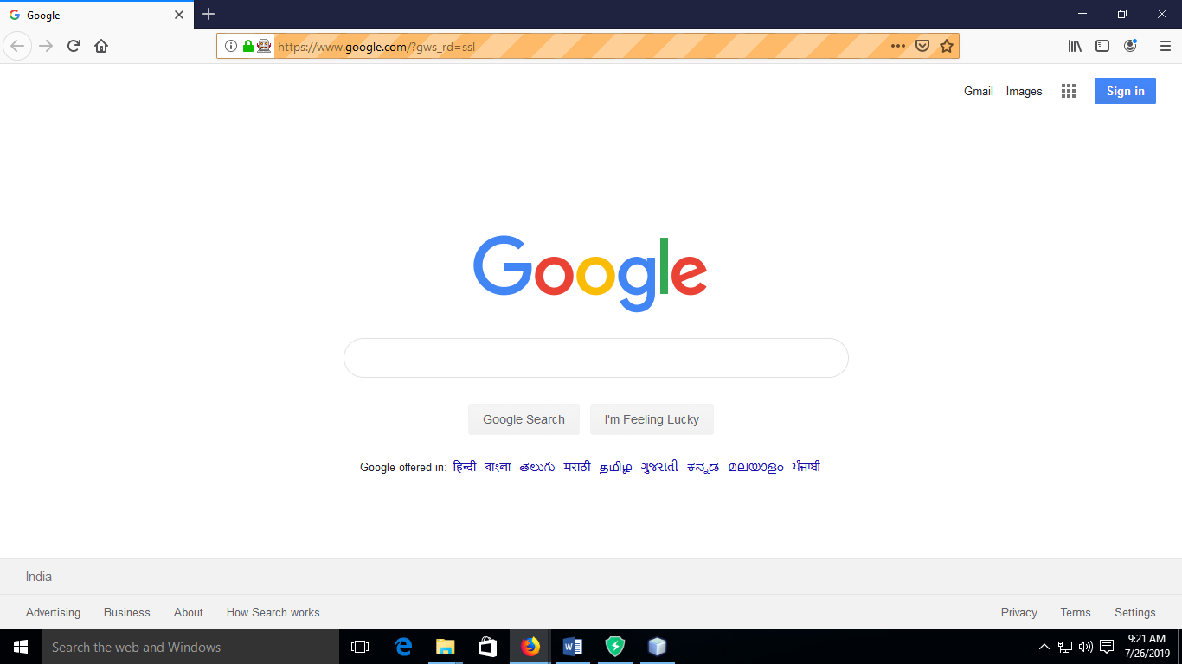

**PRACTICAL NO 5**

**Q.)Write and test a program to login a specific web page.**

**Logintest.java:**

package logintest;

import org.openqa.selenium.By;

import org.openqa.selenium.WebDriver;

import org.openqa.selenium.firefox.FirefoxDriver;

import org.openqa.selenium.remote.DesiredCapabilities;

public class Logintest {

static String driverpath="E:\\SELENIUM_i\\geckodriver.exe";

public static WebDriver driver;

public static void main(String[] args) {

System.setProperty("webdriver.gecko.driver", driverpath);

DesiredCapabilities cap=DesiredCapabilities.firefox();

cap.setCapability("marionette",true);

driver=new FirefoxDriver(cap);

driver.get("http://localhost:8080/login.html");

driver.manage().window().maximize();

driver.findElement(By.name("uname")).sendKeys("rash");

driver.findElement(By.name("upass")).sendKeys("123");

driver.findElement(By.name("b1")).click();

}}

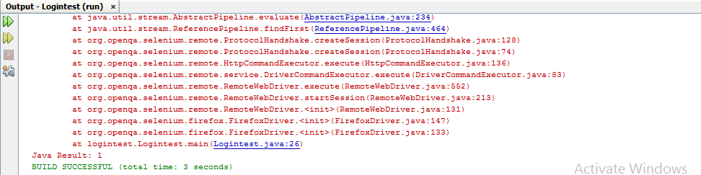

**Regi.php:**

<?php

$user=$_GET["uname"];

$upass=$_GET["upass"];

if($user=="rash" && $upass=="123")

{

echo "Login successful";

}

else

{

echo "Login failure";

}

?>

**Login.html:**

<html>

<title>LOGIN FORM</title>

<body>

<form method="get" action="regi.php">

Enter name:<input type="textbox" name="uname"><br><br>

Enter password:<input type="password" name="upass"><br><br>

<input type="submit" name="b1" value="Ok">

</form>

</html>

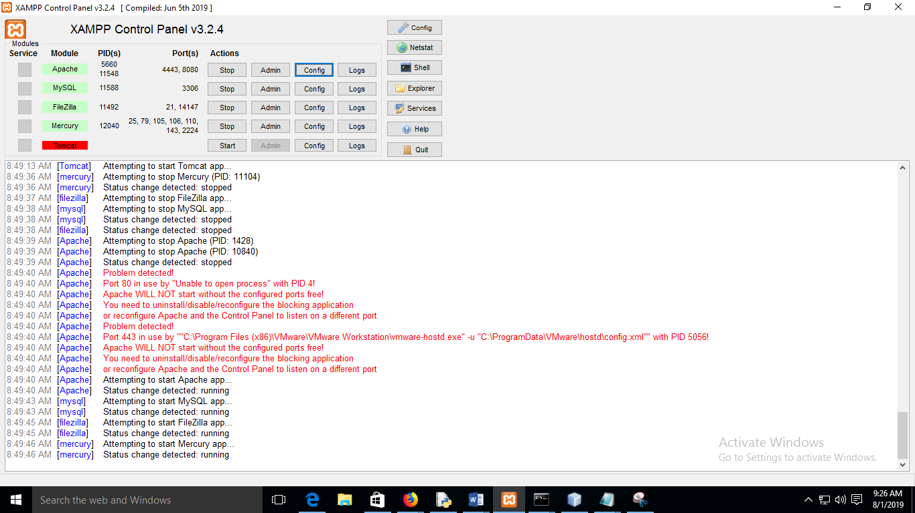

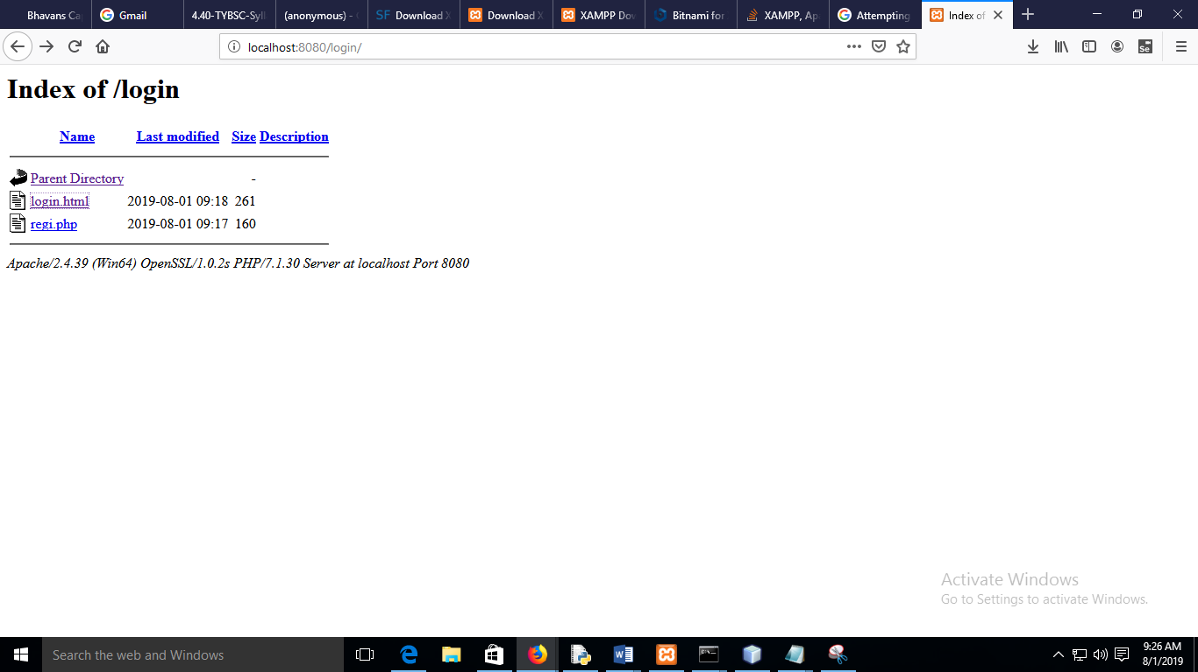

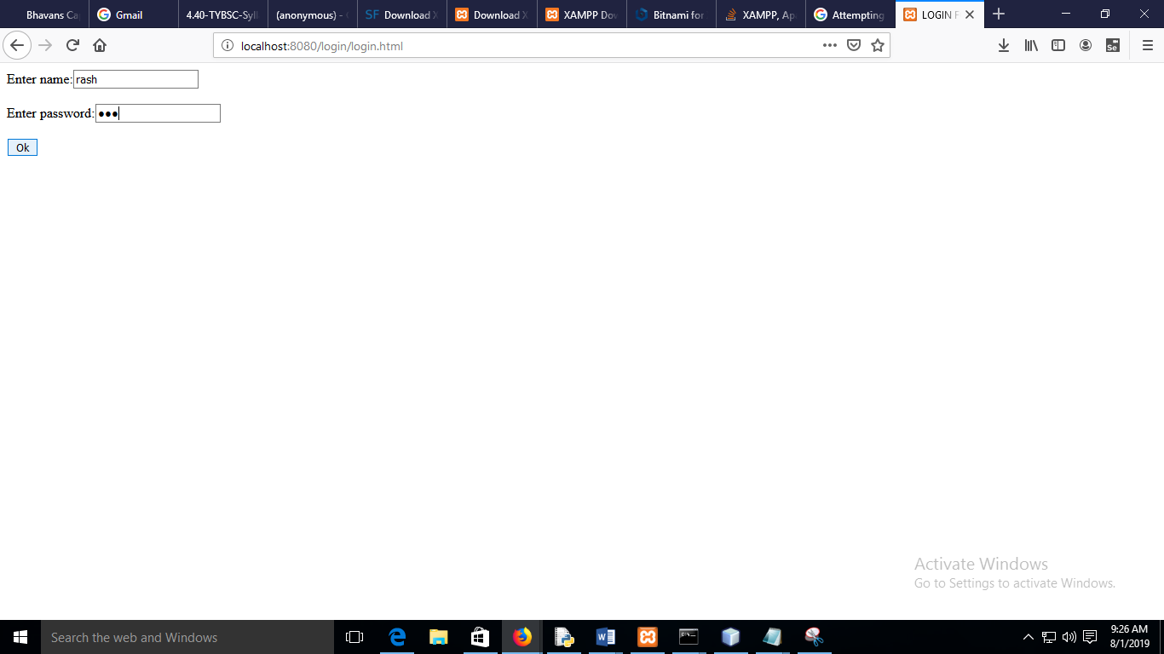

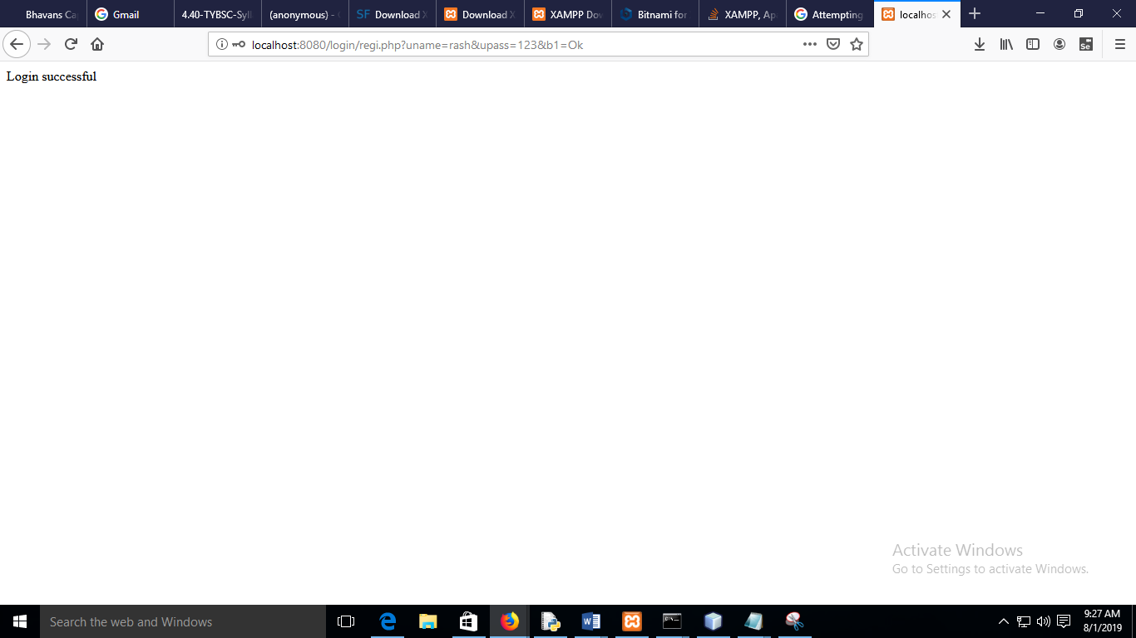

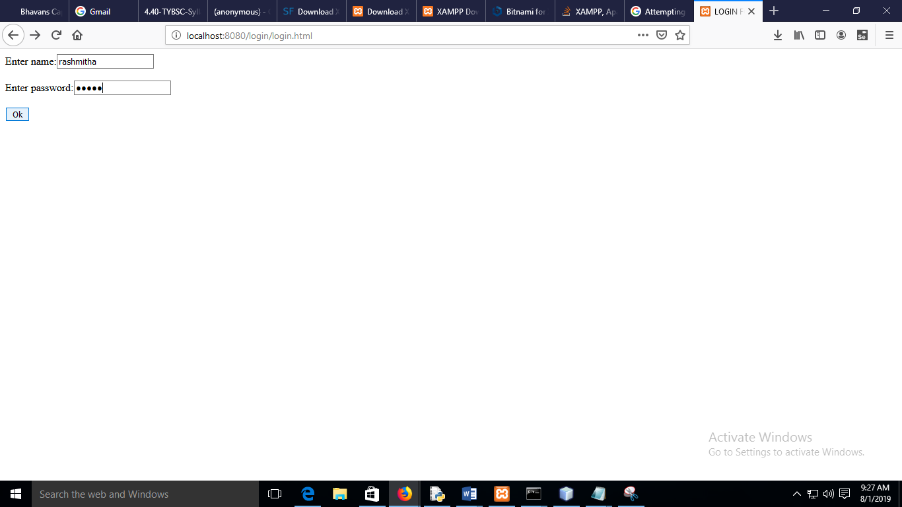

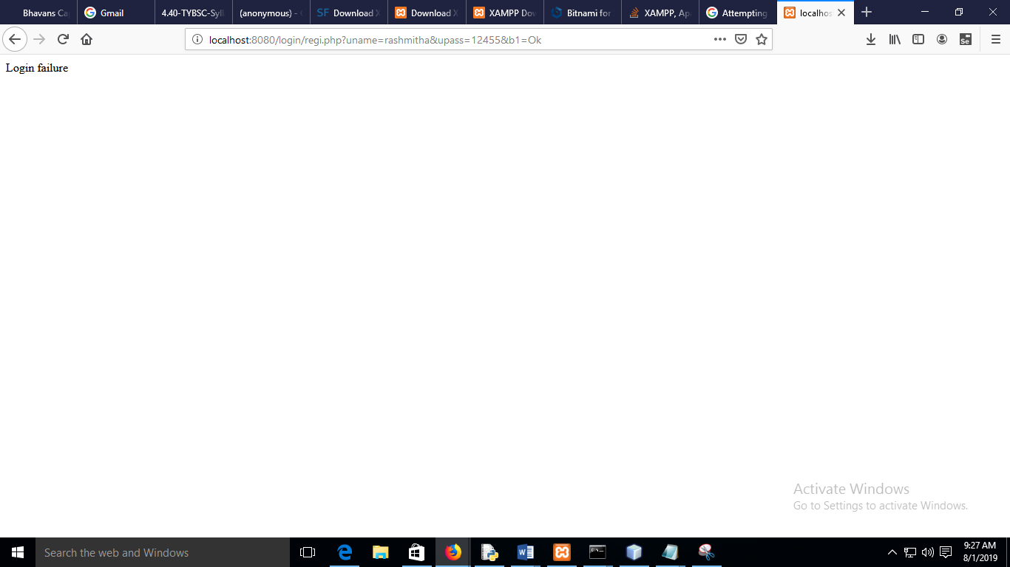

**PRACTICAL NO 6**

**Q.)Write a TestNG test case with minimum 3 test cases.**

**Part A**

First go to Tools->

**S1-create a new project**

RC on project ->others then below

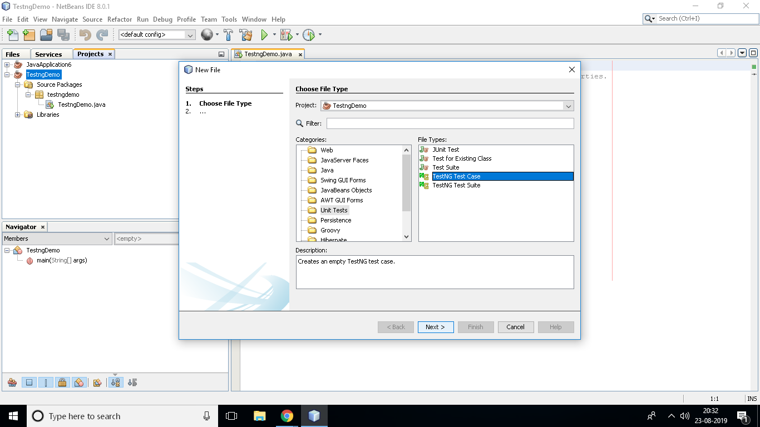

**TestingDemo.java:**

package testngdemo;

public class TestngDemo {

public static void main(String[] args) {

}

}

Demotestng.java

import org.openqa.selenium.By;

import org.openqa.selenium.WebDriver;

import org.openqa.selenium.firefox.FirefoxDriver;

import org.openqa.selenium.remote.DesiredCapabilities;

import org.testng.Assert;

import static org.testng.Assert.assertTrue;

import org.testng.annotations.AfterTest;

import org.testng.annotations.BeforeTest;

import org.testng.annotations.Test;

public class Demotestng {

String driverPath="E:\\Selenium\\geckodriver.exe";

public WebDriver driver;

@BeforeTest

public void LaunchBrowser()

{

System.out.println("launching firefox browser");

System.setProperty("webdriver.gecko.driver",driverPath);

DesiredCapabilities cap=DesiredCapabilities.firefox();

cap.setCapability("marionette",true);

driver=new FirefoxDriver(cap);

driver.get("http://www.google.com/");

driver.manage().window().maximize();

}

@Test

public void verifyHomepageTitle()

{

String expectedTitle="Google";

String actualTitle=driver.getTitle();

Assert.assertEquals(actualTitle,expectedTitle);

driver.close();

}

@Test

public void textExist()

{

if(driver.getPageSource().contains("google"))

System.out.println("Text is Present");

else

System.out.println("Text is not present");

}

@Test

public void verify()

{

if(driver.findElements(By.xpath("RASH")).size() != 0)

System.out.println("RASH is Present");

else

System.out.println("RASH is Absent");

}

@AfterTest

public void terminateBrowser()

{

driver.close();

}

public Demotestng() {

}

private void assertText(boolean contains) {

throw new UnsupportedOperationException("Not supported yet."); //To change body of generated methods, choose Tools | Templates.

}}

**Output:**

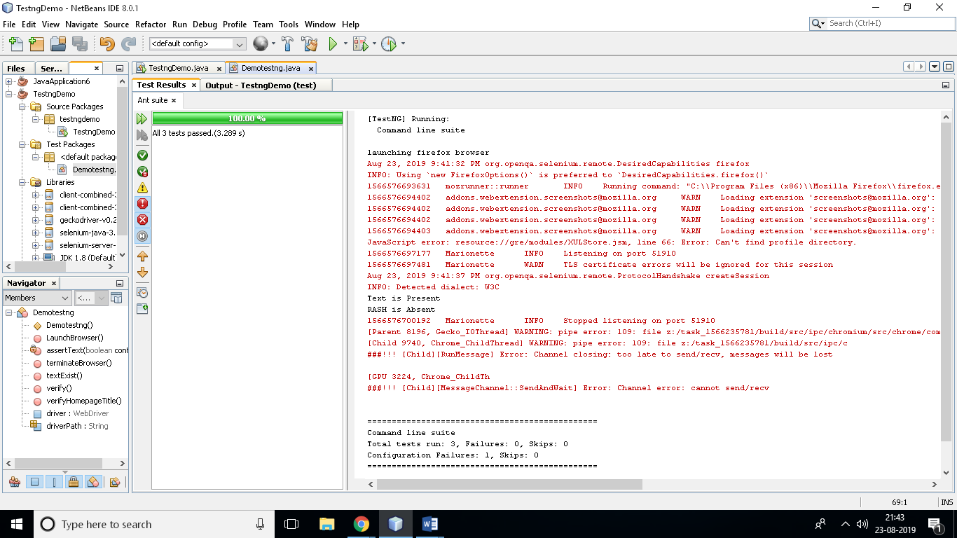

**Part B -TestNGdemo Calculator:**

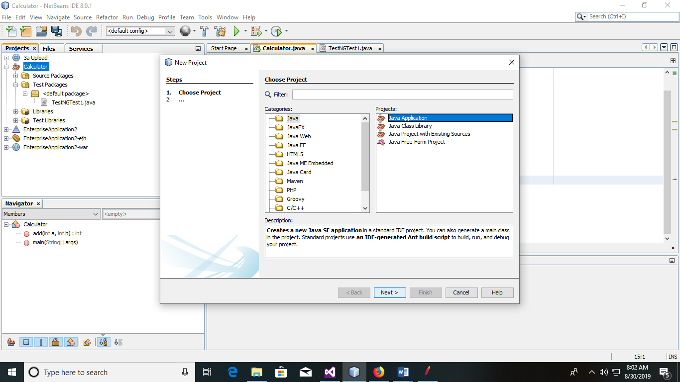

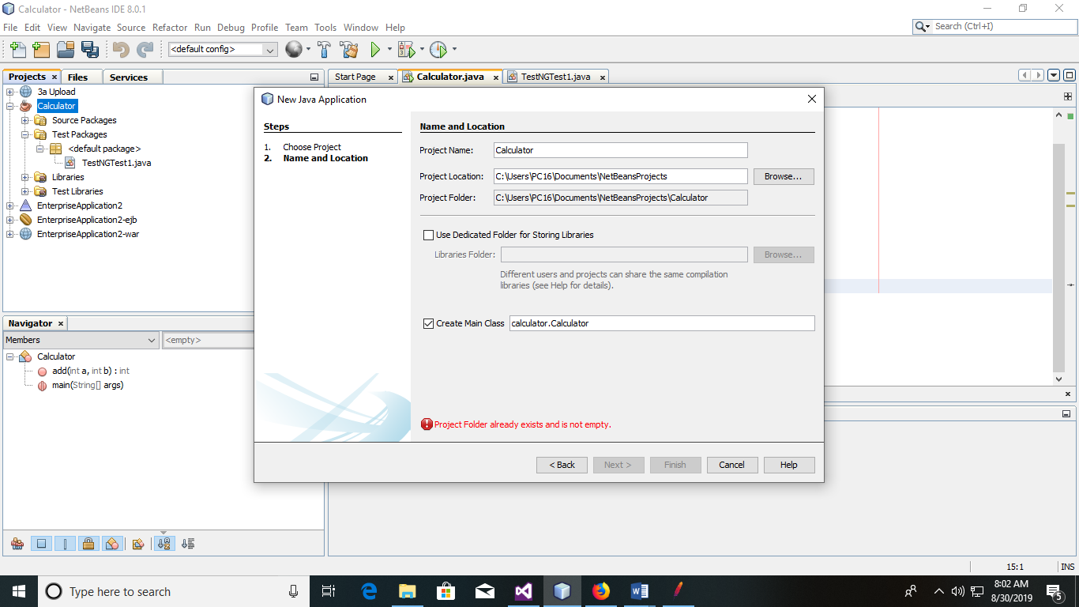

**Calculator.java:**

package calculator;

public class Calculator {

public double add(double a,double b){

returna+b;

}

public double sub(double a,double b){

return a-b;

}

public double mul(double a,double b){

return a*b;

}

public double div(double a,double b){

return a/b;

}

public static void main(String[] args) {

}

}

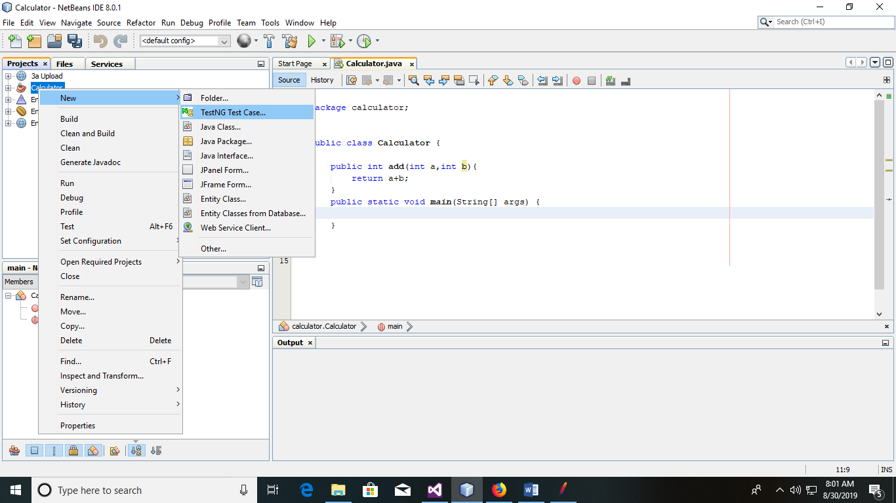

**TestNGTest1.java:**

importcalculator.Calculator;

importorg.testng.Assert;

import static org.testng.Assert.*;

importorg.testng.annotations.AfterClass;

importorg.testng.annotations.AfterMethod;

importorg.testng.annotations.BeforeClass;

importorg.testng.annotations.BeforeMethod;

importorg.testng.annotations.Test;

public class TestNGTest1 {

public TestNGTest1() {

}

@Test

public void testAddFn(){

Calculator obj=new Calculator();

Assert.assertEquals(33.0,obj.add(2.5,30.5),"Error in add()");

}

@Test

public void testsubFn(){

Calculator obj=new Calculator();

Assert.assertEquals(2.0,obj.sub(6.5,4.5),"Error in sub()");

}

@Test

public void testmulFn(){

Calculator obj=new Calculator();

Assert.assertEquals(24.0,obj.mul(6,4),"Error in mul()");

}

@Test

public void testdivFn(){

Calculator obj=new Calculator();

Assert.assertEquals(2,obj.div(60.20,10),"Error in div()");

}

}

**Output:**

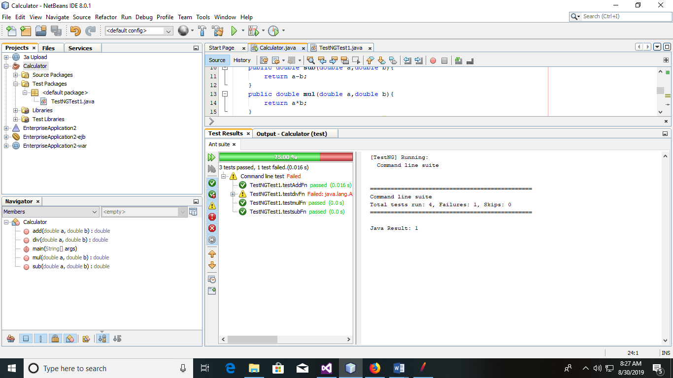

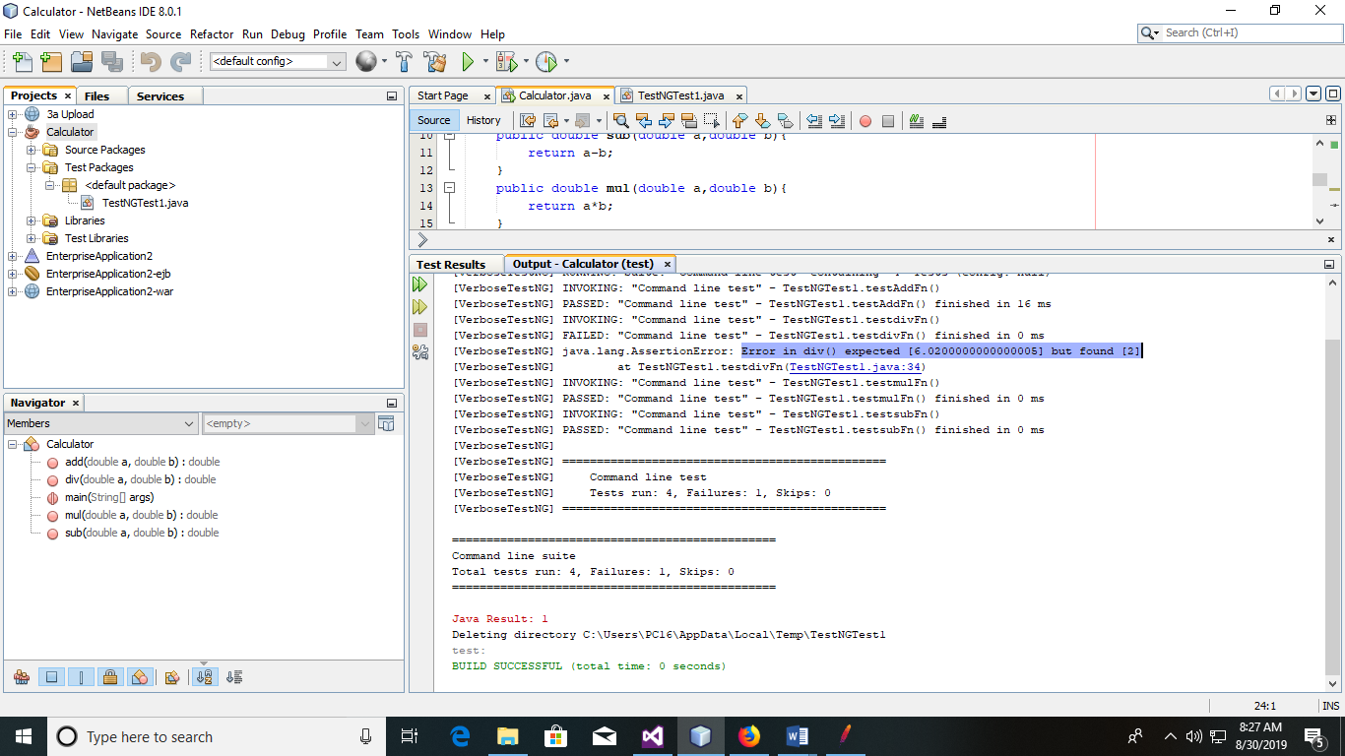

**PRACTICAL NO 7**

**Q.)Write and test a program to update 10 student records into table into Excel file (using TestNG).**

1. **Create new Java application. Right click on project and go to New>Unit tests>TestNG Test Case.**

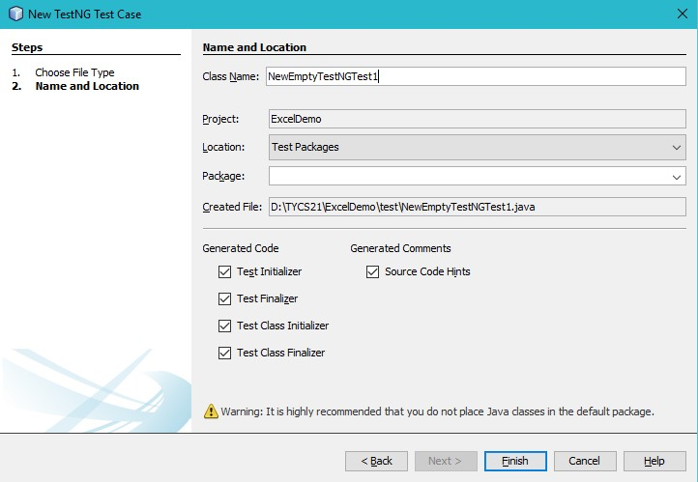

1. **Add jxl-2.6.jar file to project Libraries**
2. **Create new Excel file with .xls extension as follows.**

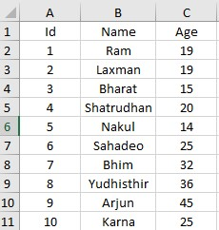

1. **Add the code below @Test annotation.**

@Test

public void testImportexport1() throws Exception {

FileInputStream fi = new FileInputStream("D:\\TYCS\\Student.xls");

Workbook w = Workbook.getWorkbook(fi);

Sheet s = w.getSheet(0);

String a[][] = new String[s.getRows()][s.getColumns()];

FileOutputStreamfo = new FileOutputStream("D:\\TYCS\\Result.xls");

WritableWorkbookwwb = Workbook.createWorkbook(fo); WritableSheetws = wwb.createSheet("result1", 0); for (int i = 0; i<s.getRows(); i++) for (int j = 0; j <s.getColumns(); j++){ a[i][j] = s.getCell(j, i).getContents(); Label l2 = new Label(j, i, a[i][j]); ws.addCell(l2);

Label l1 = new Label(3, 0, "Voting"); ws.addCell(l1);

}

for (int i = 1; i<s.getRows()-1; i++) { a[i][2] = s.getCell(2, i).getContents(); int x = Integer.parseInt(a[i][2]); if (x >=18) {

Label l1 = new Label(3, i, "Eligible"); ws.addCell(l1);

} else {

Label l1 = new Label(3, i, "Not Eligible"); ws.addCell(l1);

}

}

System.out.println("Records sucessfully updated "); wwb.write(); wwb.close(); }

**Output:**

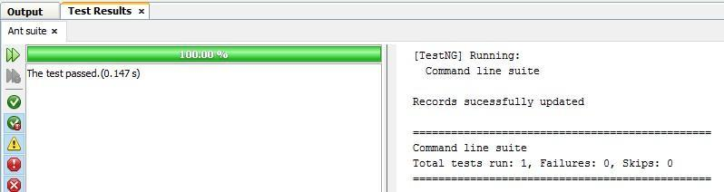

**Result.xls file is generated.**

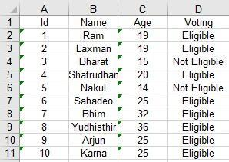

**PRACTICAL NO 8**

**Q.)Write and test a program to select the number of students who have scored more than 60 in any one subject (or all subjects) (using TestNG).**

**Prerequisites:** jxl-2.6.jar AND org-netbeans-modules-testng.nbm plugin.

**Students.xls**

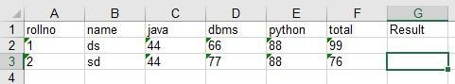

**NewEmptyTestNGTest.java:**

@Test

public void testImportexport1() throws Exception {

FileInputStream fi = new FileInputStream("E:\\student.xls");

Workbook w = Workbook.getWorkbook(fi);

Sheet s = w.getSheet(0);

String a[][] = new String[s.getRows()][s.getColumns()];

FileOutputStreamfo = new FileOutputStream("E:\\result.xls");

WritableWorkbookwwb = Workbook.createWorkbook(fo);

WritableSheetws = wwb.createSheet("result1", 0);

for (int i = 0; i<s.getRows(); i++) {

for (int j = 0; j <s.getColumns(); j++) {

a[i][j] = s.getCell(j, i).getContents();

Label l2 = new Label(j, i, a[i][j]);

ws.addCell(l2);

Label l1 = new Label(6, 0, "Result");

ws.addCell(l1);

} }

for (int i = 1; i<s.getRows(); i++) {

for (int j = 2; j <s.getColumns(); j++) {

a[i][j] = s.getCell(j, i).getContents();

int x = Integer.parseInt(a[i][j]);

if (x > 60) {

Label l1 = new Label(6, i, "Selected");

ws.addCell(l1);

break;

} else {

Label l1 = new Label(6, i, "Not selected");

ws.addCell(l1);

}

}

System.out.println("Records sucessfully updated ");

}

wwb.write(); wwb.close(); }

**Output: Result.xls:**

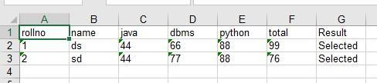

**PRACTICAL NO 9**

**Q.)Write and test a program to count the number of links available on the webpage.**

**Step1-open a notepad file and name it as Countlink.html and save in as below(inside htdocs)**

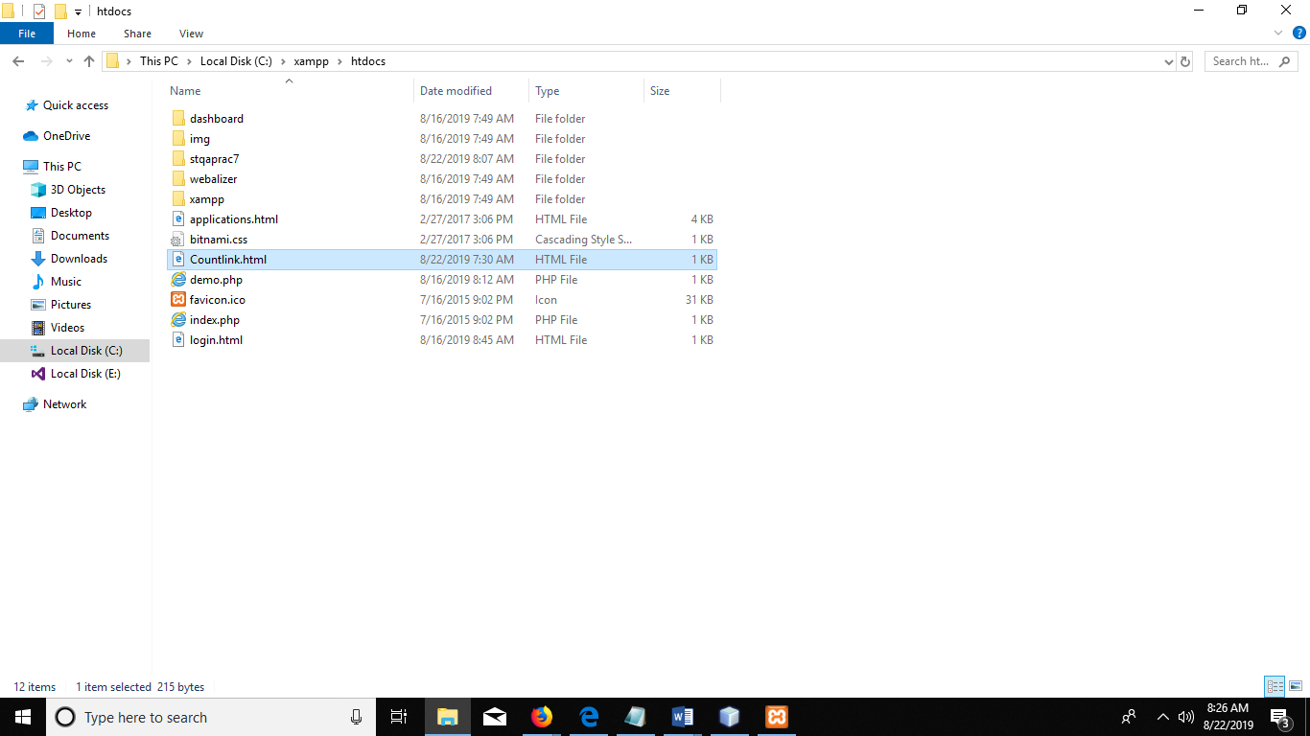

<html>

<a href="http://www.google.com/">Google</a><br>

<a href="http://www.yahoo.com/">Yahoo</a><br>

<a href="http://www.wikipedia.com/">Wikipedia</a><br>

<a href="http://www.github.com/">Github</a><br>

</html***>***

**Step 2 now go to netbeans prepare a java file and write the following code**

**Countlinks.java:**

package countlinks;

import org.openqa.selenium.By;

import org.openqa.selenium.WebDriver;

import org.openqa.selenium.WebElement;

import org.openqa.selenium.firefox.FirefoxDriver;

import org.openqa.selenium.remote.DesiredCapabilities;

public class Countlinks {

static String driverPath="E:\\Selenium\\geckodriver.exe";;

static WebDriver driver;

public static void main(String[] args) {

System.setProperty("webdriver.gecko.driver", driverPath);

DesiredCapabilities cap=DesiredCapabilities.firefox();

cap.setCapability(("marionette"), true);

driver=new FirefoxDriver(cap);

driver.get("http://localhost:4040/Countlink.html");

driver.manage().window().maximize();

java.util.List<WebElement>links=driver.findElements(By.tagName("a"));

System.out.println("total no of links="+links.size());

System.out.println("Name of the links are:");

for (int i=0;i<links.size();i++)

{

System.out.println("Link name is:"+links.get(i).getText());

}

}

}

**Step3-now run xampp apache**

**Step 4- now run the java file**

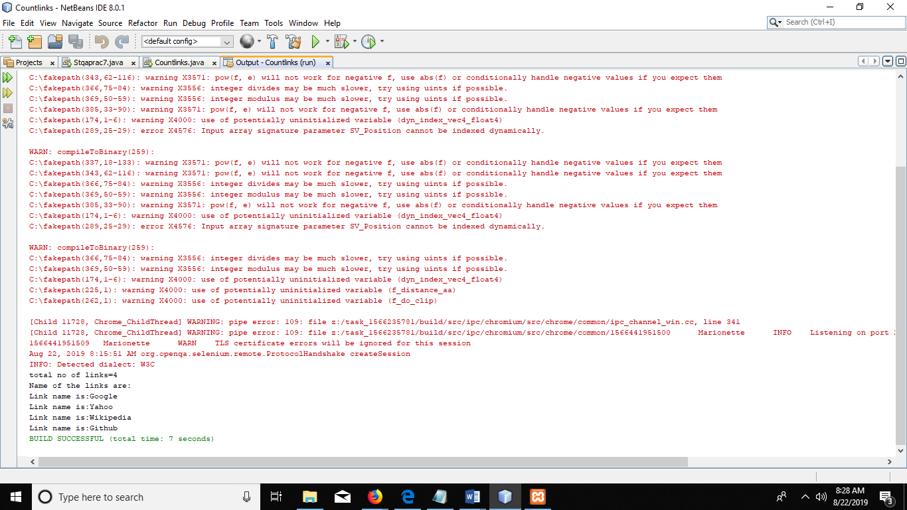

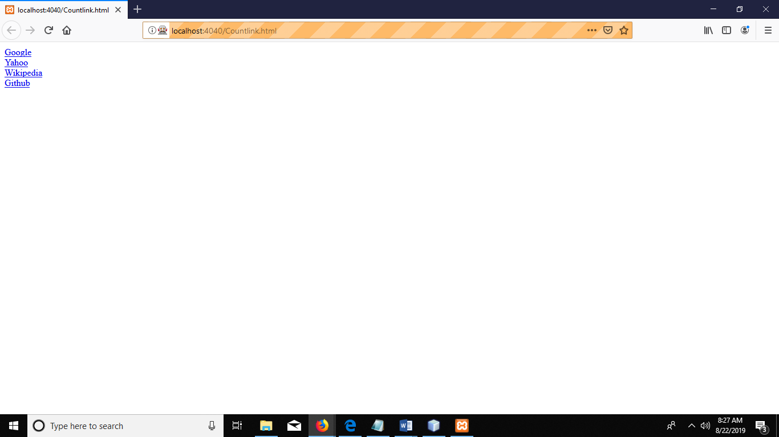

Go back to the java output screen



**PRACTICAL NO 10**

**Q.)Write and test a program to get the number of items in a list / combo box**

**Step 1-create a html file named Countitems**

<html>

<body>

<select name="menu">

<option value="0" selected>Apple</option>

<option value=1">Mango</option>

<option value=2">Banana</option>

<option value=3">Grapes</option>

<option value=4">Peach</option>

</select>

</body>

</html>

**Step2-add a new java class named Countitems**

package countitems;

import org.openqa.selenium.By;

import org.openqa.selenium.WebDriver;

import org.openqa.selenium.WebElement;

import org.openqa.selenium.firefox.FirefoxDriver;

import org.openqa.selenium.remote.DesiredCapabilities;

public class Countitems {

static String driverPath="E:\\Selenium\\geckodriver.exe";;

static WebDriver driver;

public static void main(String[] args) {

System.setProperty("webdriver.gecko.driver", driverPath);

DesiredCapabilities cap=DesiredCapabilities.firefox();

cap.setCapability(("marionette"), true);

driver=new FirefoxDriver(cap);

driver.get("http://localhost:4040/Countitems.html");

driver.manage().window().maximize();

java.util.List<WebElement>items=driver.findElements(By.xpath("//select/option"));

System.out.println("total no of items="+items.size());

System.out.println("Name of the items are:");

for (int i=0;i<items.size();i++)

{

System.out.println("Item name is:"+items.get(i).getText());

}}}

**step 3-now execute java file**

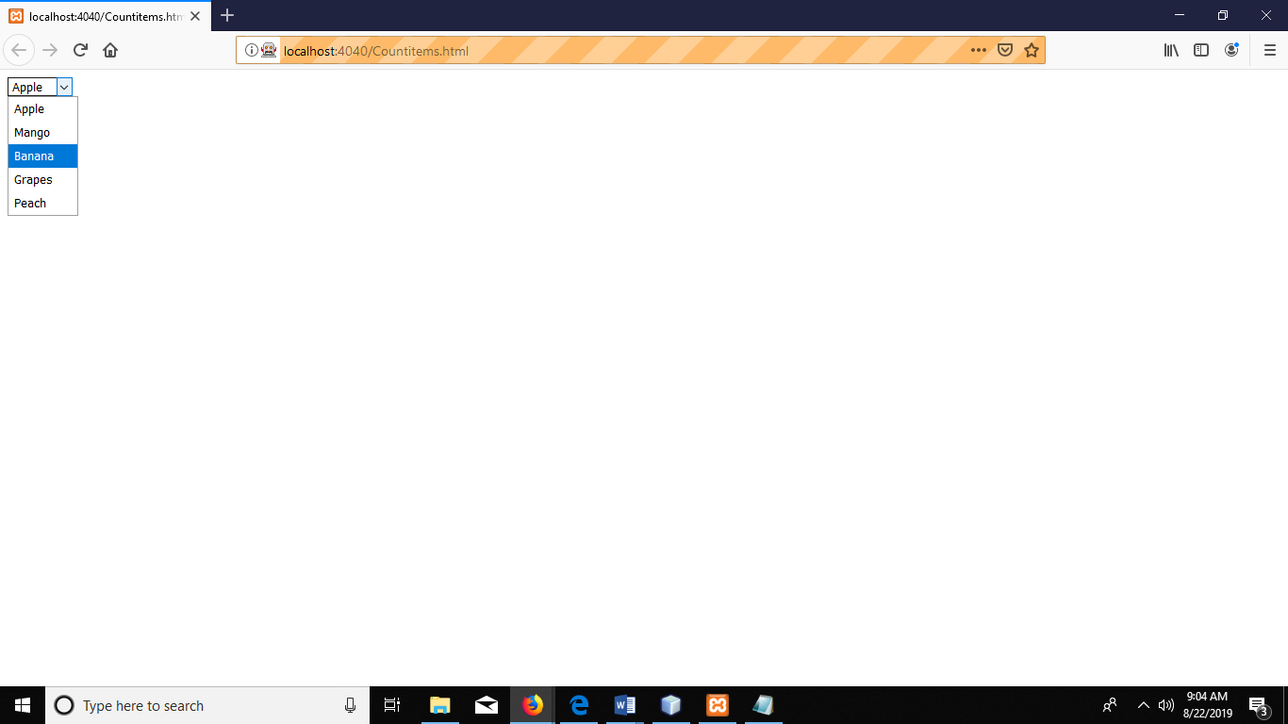

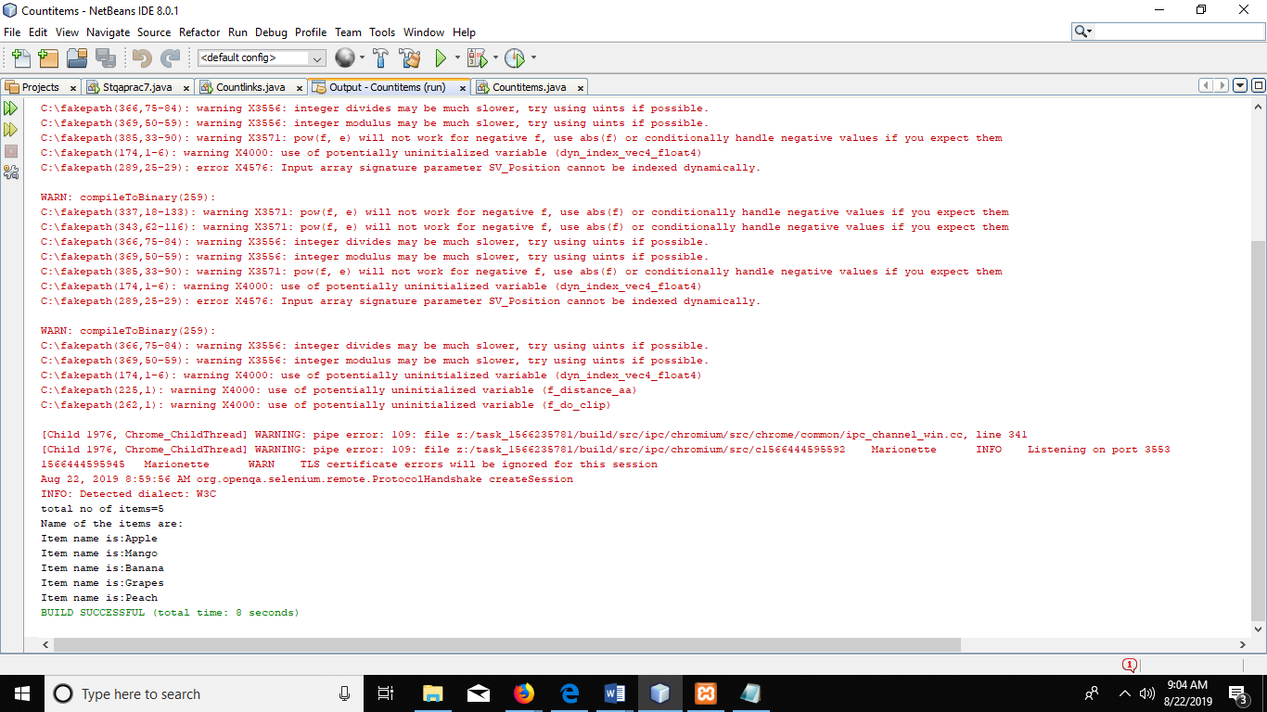

**PRACTICAL NO 11**

**Q.)Write and test a program to count the number of check boxes on the page checked and unchecked count**

**Step1-create a html file named Countcheckbox**

<html>

<body>

<form>

<input type="checkbox">Football<br>

<input type="checkbox">Music<br>

<input type="checkbox">Dancing<br>

</form>

</body>

</form>

**Step2-create a java file**

package countitems;

import org.openqa.selenium.By;

import org.openqa.selenium.WebDriver;

import org.openqa.selenium.WebElement;

import org.openqa.selenium.firefox.FirefoxDriver;

import org.openqa.selenium.remote.DesiredCapabilities;

public class Countitems {

static String driverPath="E:\\Selenium\\geckodriver.exe";;

static WebDriver driver;

public static void main(String[] args) {

System.setProperty("webdriver.gecko.driver", driverPath);

DesiredCapabilities cap=DesiredCapabilities.firefox();

cap.setCapability(("marionette"), true);

driver=new FirefoxDriver(cap);

driver.get("http://localhost:4040/Countitems.html");

driver.manage().window().maximize();

java.util.List<WebElement>items=driver.findElements(By.xpath("//select/option"));

System.out.println("total no of items="+items.size());

System.out.println("Name of the items are:");

for (int i=0;i<items.size();i++)

{

System.out.println("Item name is:"+items.get(i).getText());

}}}

**OUTPUT:**

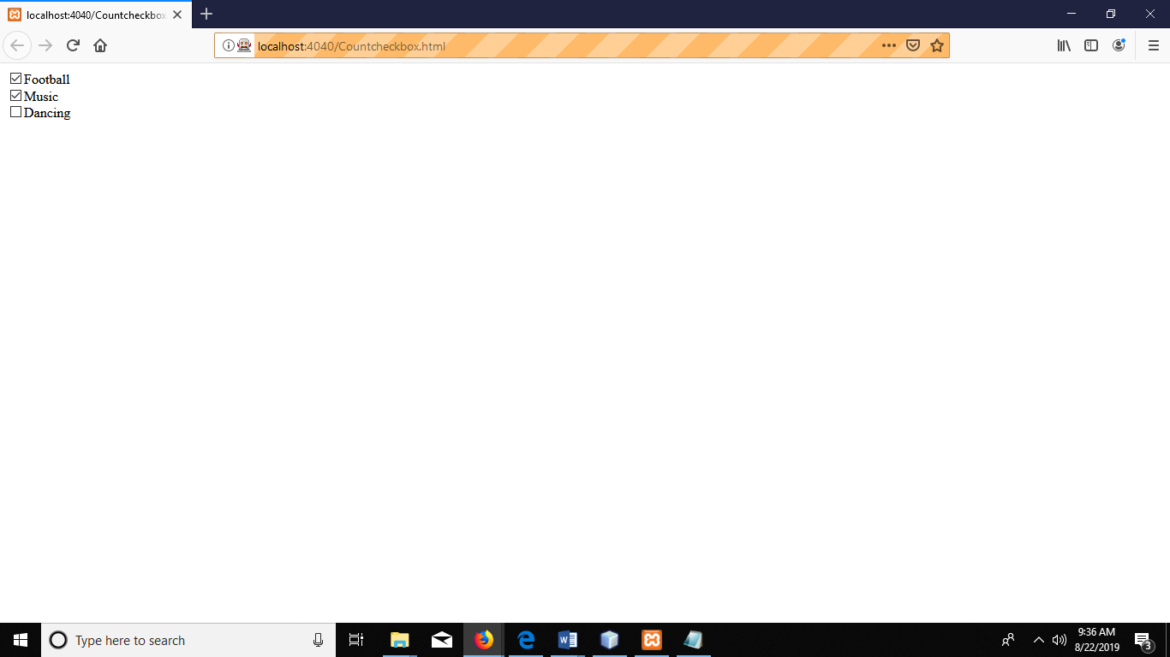

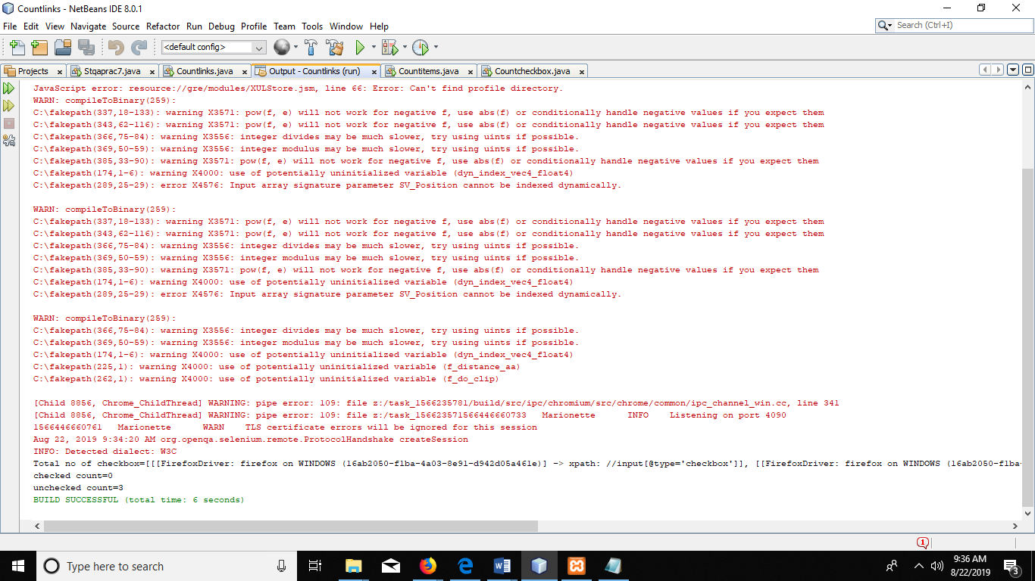

**PRACTICAL NO 12**

**Q.)Load Testing using JMeter, Android Application testing using Appium Tools, Bugzilla Bug tracking tools**

D.C on jmeter.bat file (For running this we require jdk min 8 version)

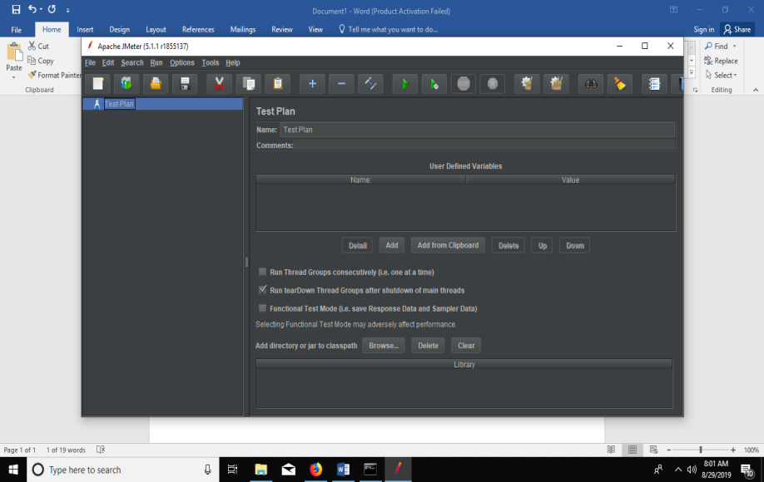

S1

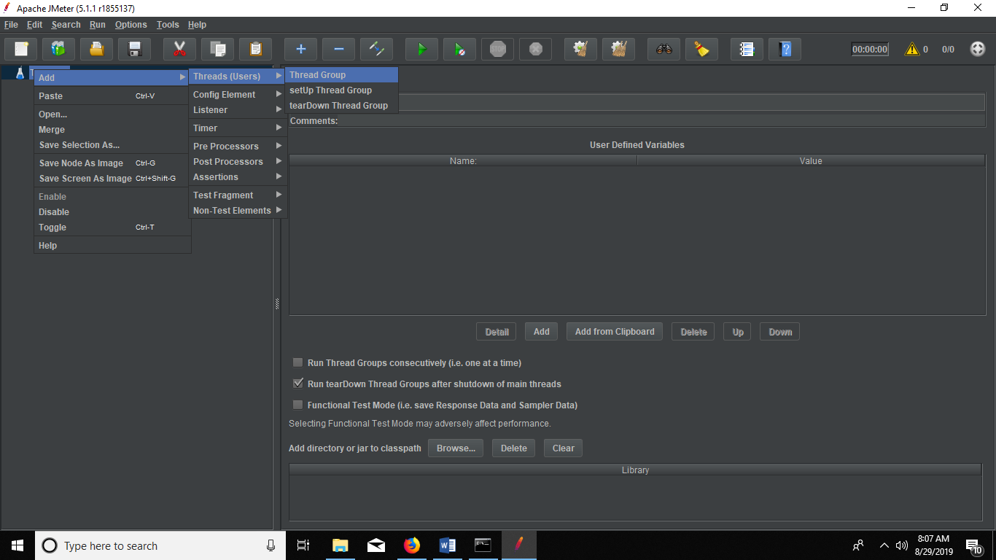

S2

